**Support information**

**Trimethoxyboroxine as an electrolyte additive to enhance the 4.5 V cycling performance of Ni-rich layered oxide cathode**

Wei Gu1,#, Guoyong Xue1,#, Qingyu Dong1, Ruowei Yi1, Yayun Mao1, Lei Zheng1, Haikuo Zhang3, Xiulin Fan3, Yanbin Shen1,* and Liwei Chen1,2,*

1 *i-Lab, CAS Center for Excellence in Nanoscience, Suzhou Institute of Nano-Tech and Nano-Bionics, Chinese Academy of Sciences, Suzhou 215123, China*

2 *School of Chemistry and Chemical Engineering, Shanghai Jiao Tong University, Shanghai 200240, China*

*3 State Key Laboratory of Silicon Materials, School of Materials Science and Engineering, Zhejiang University, Hangzhou 310027, China*

# The equally contributed authors.

*Corresponding author.

*E-mail:* ybshen2017@sinano.ac.cn (Y. B. Shen), and lwchen2018@sjtu.edu.cn (L. W. Chen)

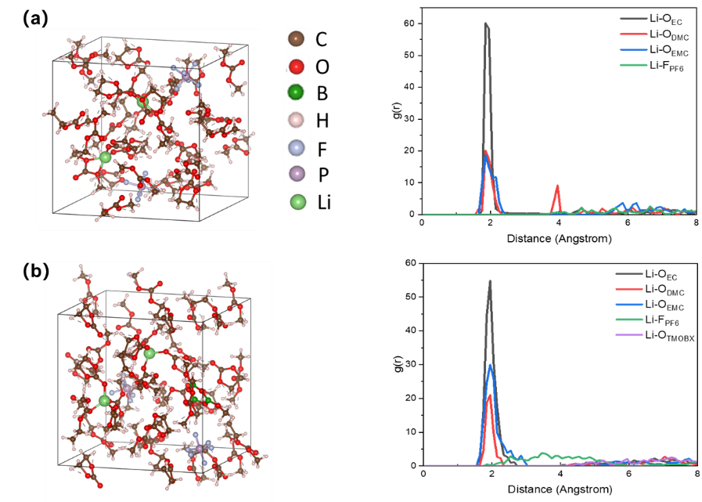

**Fig. S1.** The solvation structure of (a) blank electrolyte and (b) TMOBX-containing electrolyte.

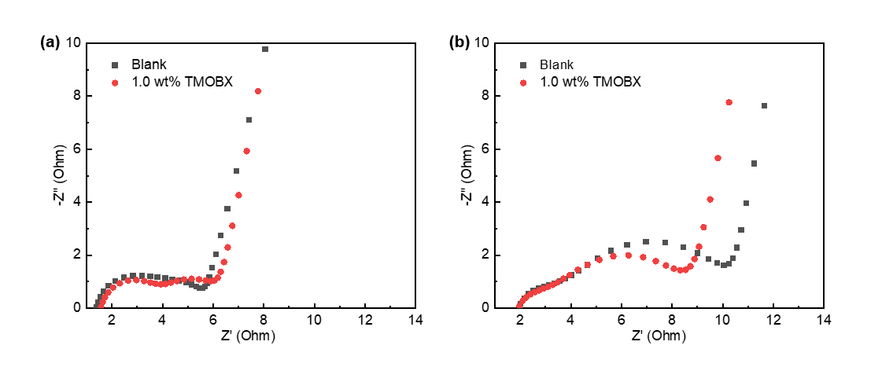

**Fig. S2.** The Nyquist plots of Li‖NCM811 cells with blank electrolyte and TMOBX-containing electrolyte after activation at 0.2C for 3 cycles (a), and after cycling at 0.5C for 30 cycles (b)

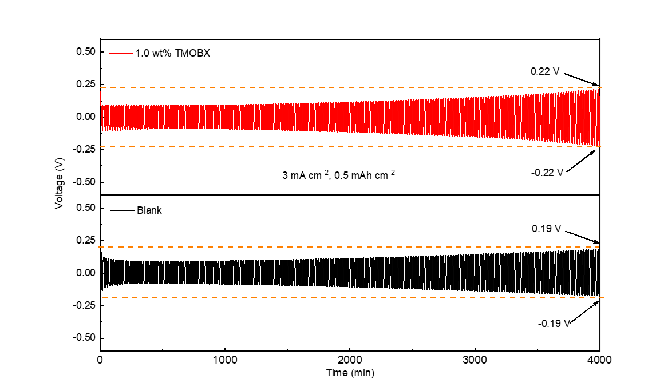

**Fig. S3.** The time-voltage profiles of Li‖Li symmetric cells with and without 1.0 wt.% TMOBX addition at a current density of 3 mA cm-2.

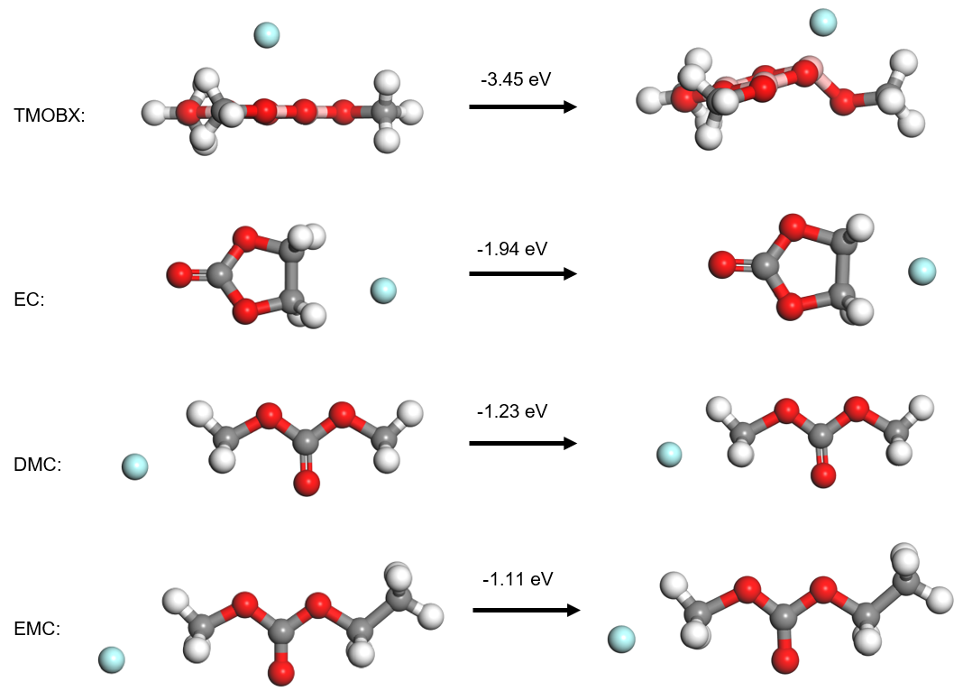

**Fig. S4.** Optimized geometries of F- trapped TMOBX, EC, DMC and EMC molecules with corresponding binding energy.

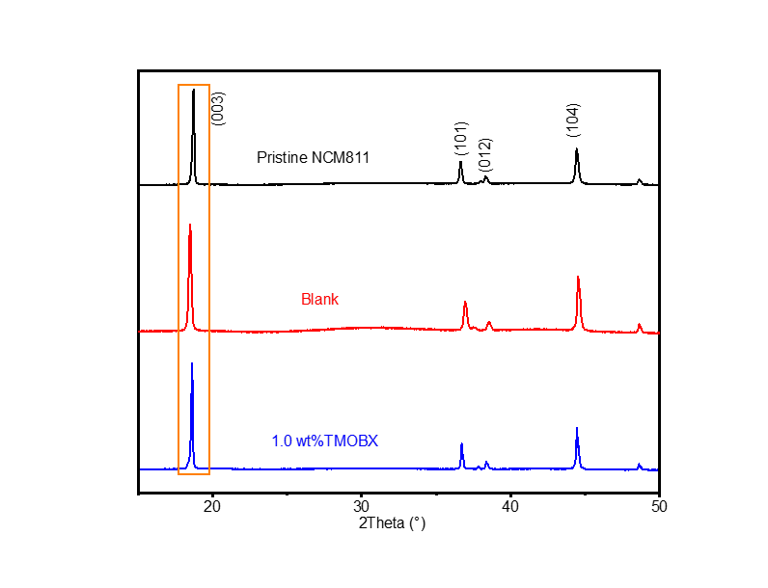

**Fig. S5.** Comparison of the XRD spectra of the pristine NCM811 and the NCM811 after 200 cycles using different electrolytes.