A first-principles study on the electrochemical reaction activity of 3d transition metal single-atom catalysts in nitrogen-doped graphene: trends and hints
Caiyan Zheng¹, Xu Zhang², Zhen Zhou², Zhenpeng Hu^{1*}
¹ School of Physics, Nankai University, Tianjin 300071, China
² School of Materials Science and Engineering, Institute of New Energy Material Chemistry, Key Laboratory of Advanced Energy Materials Chemistry (Ministry of Education), Renewable Energy Conversion and Storage Center (ReCast), Nankai University, Tianjin 300350, China

*Corresponding author.
E-mail: zphu@nankai.edu.cn

Supporting information

Reliability of data based on spin states
In the work of Lin et al. [1], a machine learning (ML) model was trained based on data from their previous work [2]. The spin states of single-atom catalysts (SACs) were not correctly treated in Ref. 2, resulting in the calculations yielding unreliable results in terms of physics. Consequently, the ML model in Ref. 1 was trained using the unreliable data from Ref. 2 and therefore is unconvincing.
According to Pauli’s Exclusion Principle, the magnetic moment should be determined by the unpaired electrons in the system. This is a basic principle in physics that one should obey, but the data in Ref. 2 does not. For example, as shown in Table S1, Fe supported on a single vacancy with three carbon atoms (FeC₃-SV) has a magnetic moment of 1 in Ref. 2 (Table S1 and Table 34 in the supplementary materials of Ref. 2). Since the electron numbers of C and Fe in FeC₃-SV are all even, the unpaired electrons (magnetic moment) should be even, rather than 1. This results in an incorrect ground state energy as well as free energy difference ($∆G$). For example, FeC₃-SV (${∆G}_{*H}=-0.00 eV$) and TcC₃-SV (${∆G}_{*H}=-0.03 eV$) have outstanding HER performance in the study by Choi et al. [3], while the HER activity of Fe/TcC₃-SV (Table S1 and Table 3 in the supplementary materials of Ref. 2) in the training data is relatively poor. The difference originates from the use of incorrect spin states, which can be proven by the following test calculation.
Based on Pauli’s Exclusion Principle, several spin states of each model were calculated, and the lowest energy one has been adopted. Following this protocol, the testing results match the ones in Ref. 3 well for FeC₃-SV and TcC₃-SV (Table S1). Keeping this fundamental principle in mind, it is easy to explain why our data ($η_{ZnN1-G}$=0.71 V, $η_{ZnN2-G}$=0.47 V, $η_{ZnN3-G}$=0.49 V, $η_{ZnN4-G}$=0.54 V) match the experimental observations [4,5] of ZnN_{x}-G catalysts’ excellent ORR activity, but the data in Ref. 1 and 2 ($η_{ZnN1-G}$=0.89 V, $η_{ZnN2-G}$=1.44 V, $η_{ZnN3-G}$=2.04 V, $η_{ZnN4-G}$=1.33 V) do not. This also explains the large difference between the NiN₄-G’s HER activity result in Ref. 2 (${∆G}_{*H}$ = 0.22 eV) and an experimental result (${∆G}_{*H}$ = 1.62 eV [6]), as well as the results in other theoretical studies (${∆G}_{*H}$ = 1.20 eV [7], 1.35 eV [8], and 1.68 eV from our calculations).

Table S1. The magnetic moment of a single metal atom supported on a single vacancy with three carbon atoms (MC₃-SV) without adsorbates, and the adsorption free energy of H on the MC₃-SV (${∆G}_{*H}$).
Metal | Magnetic moment | $${∆G}_{*H}/eV$$ | Reference
FeC₃-SV | 1 | -0.45 | Ref. 2 (U_{Fe_d}= 3.29 eV)
 | 2 | 0.02 | Test (U_{Fe_d}= 3.29 eV)
 | 0 | 0.01 | Test (no U)
 | - | 0.00 | Ref. 3 (no U)
TcC₃-SV | 1.99 | -0.37 | Ref. 2
 | 1 | -0.12 | Test
 | - | -0.03 | Ref. 3

2. Free energy calculation and machine learning method

Free energy calculation
For the elementary reaction, the Gibbs free energy change ($∆G$) is estimated by the relation:
$∆G=∆E+∆E_{ZPE}-T∆S$ (S1)
where $∆E$ is the energy difference between products and reactants as obtained from calculation, T is room temperature (298.15 K), and $∆E_{ZPE}$ and $∆S$ are the changes in the zero-point energy and entropy, respectively. The entropy for gas-phase molecules such as H₂ can be obtained from the NIST database [9]. For adsorbed species, $∆E_{ZPE}$ and $∆S$ are calculated using the following formulae:
$E_{ZPE}=\sum_{i}{\frac{1}{2}hv_{i}}$ (S2)
$S_{vib}=R\sum_{i}{(\frac{\frac{Θ_{vi}}{T}}{\exp\left(\frac{Θ_{vi}}{T}\right)-1}-ln⁡[1-exp⁡(\frac{-Θ_{vi}}{T})])}$ (S3)
where the characteristic vibrational temperature $Θ_{vi}$ is equal to $hv_{i}/k_{B}$, and $h$, $v_{i}$, $k_{B}$, $S_{vib}$, $R$, and $T$ are the Planck constant, vibrational frequency, Boltzmann constant, vibrational entropy, gas constant, and temperature, respectively. In the frequency calculation, only the adsorbed atoms above the surface move, and the other atoms are fixed. We used the model proposed by Nørskov et al. [10], so the free energy of ${(H}^{+}+e^{-}$) at $pH=0$, $T=$ 298.15 K, and electrode potential $U=0 V$ was calculated using the free energy of 1/2 H₂. Given that the free energy of gaseous water is equal to that of liquid water with a pressure of 0.035 bar at 298.15 K, gas-phase water at 0.035 bar was selected as the reference state. The free energy of O₂ was obtained using $G_{O_{2}(g)}=2G_{H_{2}O(l)}-2G_{H_{2}(g)}+4.92 eV$, due to the poor description of the O₂ high-spin ground state in DFT calculations [11].
The recommended PAW potentials in the VASP manual were applied (Table S2). To reduce the influence of different spin configurations on energy, several spin states were studied for each model. For example, on a pure CoN₃-G surface, the energy with magnetic moments of 0, 2, and 4 was considered, as the total number of electrons was even. Then the lowest energy (mag = 0) was adopted (Table S3). Similarly, the energies of the multiple spin states of *OOH, *O, *OH, and *H systems were also considered, and the lowest one was selected for subsequent reaction calculations.

Machine learning method
For the ML method, the eXtreme Gradient Boosting (XGBoost) algorithm [12] was adopted, and the ML models were achieved using the scikit-learn package [13]. The impact of each feature was investigated using the Gini importance method [14]. XGBoost is an ensemble of decision trees (DT) and has been dominating Kaggle competitions. In the Gradient Boosting DT, the new regression models were sequentially created and the residuals made by prior models were reduced. The predicted value was obtained using the weighted sum of each sub-model:
$f=\sum_{k}^{K}{f_{k}(x_{i})}$ (S4)
in which K stands for the number of sub-models, $x$ stands for the input features, and $f(x)$ represents the sub-models. All the hyper-parameters were optimized until the best results were found. Generally, different ML models possess different indices to evaluate their prediction accuracy. We employed three indices to evaluate the prediction accuracy: coefficient of determination (R²), mean squared error (MSE), and Pearson correlation coefficient (r).
R² is used to evaluate the fitness between actual and predicted values and is defined as:
$R^{2}=1-\frac{\sum_{i}{{(y_{i}-f_{i})}^{2}}}{\sum_{i}{{(y_{i}-\overline{y})}^{2}}}$ (S5)
in which y stands for the values calculated by DFT, $f$ stands for the values predicted by ML models, and $\overline{y}$is the average value. The closer R² is to 1, the better the fit between the predicted and actual values.
The MSE stands for the degree of variance between actual and predicted values, given by:
$MSE=\frac{1}{N}\sum_{i}^{n}{{(y_{i}-f_{i})}^{2}}$ (S6)
The Pearson coefficient ($r$) represents the linear correlation between actual and predicted values, defined as:
$r= \frac{\sum_{i}{(y_{i}-\overline{y})(f_{i}-\overline{f})}}{\sqrt{\sum_{i}{{(y_{i}-\overline{y})}^{2}}}\sqrt{\sum_{i}{{(f_{i}-\overline{f})}^{2}}}}$ (S7)
where the value of r is between –1 and 1, and the closer the absolute value of r is to 1, the stronger the linear correlation.
Variance ($S^{2}$) is used to measure the degree of deviation between a set of data and its expected value:
$S^{2}=\frac{1}{N}\sum_{i}{{(x_{i}-\overline{X})}^{2}}$ (S8)
where $x_{i}$ represents the ${∆G}_{*H}$ values calculated by DFT, and the average value $\overline{X}$ is taken as zero here. A small $S^{2}$ value means that the data is close to the expected value.

3. Figures and tables

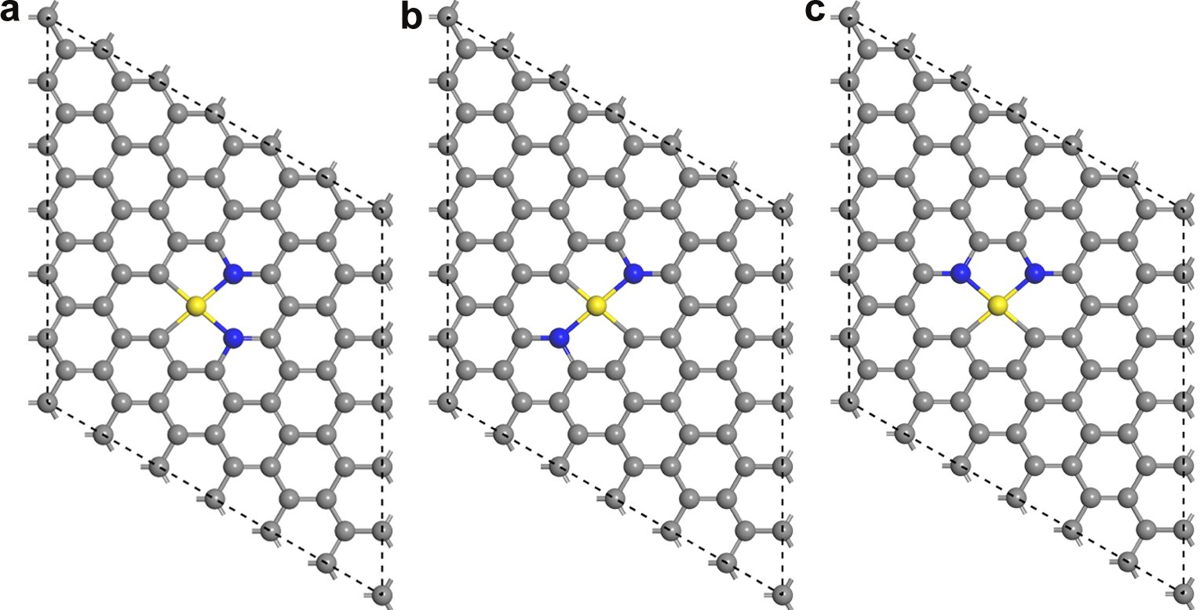

Figure S1. Three configurations of MN₂-G. (a) MN₂₁-G. (b) MN₂₂-G. (c) MN₂₃-G. The yellow, blue, and grey balls represent transition metal, nitrogen, and carbon atoms, respectively.

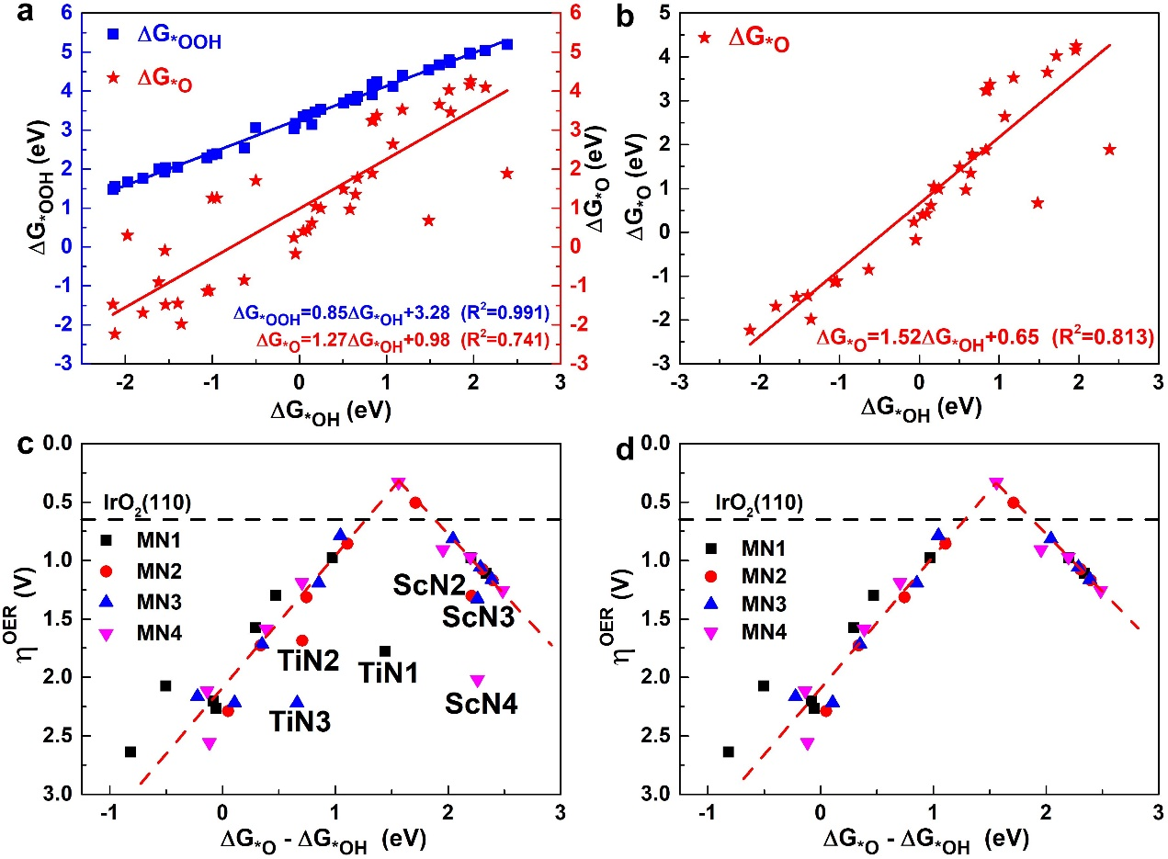

Figure S2. Linear relationship of $∆G_{*O}$ vs. $∆G_{*OH}$, and the relationship between OER overpotential $η^{OER}$ and ($∆G_{*O}-∆G_{*OH}$) (a, c) before and (b, d) after removing the points with different rate-determining steps.

Table S2. Recommended PAW potentials of each atom in the VASP manual.
Atoms | Pseudopotential | Valency
H | H | 1
C | C | 4
N | N | 5
O | O | 6
Sc | Sc_sv | 11
Ti | Ti_sv | 12
V | V_sv | 13
Cr | Cr_pv | 12
Mn | Mn_pv | 13
Fe | Fe | 8
Co | Co | 9
Ni | Ni | 10
Cu | Cu | 11
Zn | Zn | 12

Table S3. Magnetic moment ($μ_{B}$) and corresponding electron energies (eV) for CoN₃-G structure.
Systems | Mag | Energy | ∆E
surface | 0 | -647.40040 | 0.00
 | 2 | -647.36164 | 0.04
 | 4 | -646.14484 | 1.26
*OOH | 1 | -662.13582 | 0.00
 | 3 | -661.68175 | 0.45
 | 5 | -660.45910 | 1.68
*O | 0 | -652.60038 | 0.38
 | 2 | -652.97767 | 0.00
 | 4 | -652.36725 | 0.61
*OH | 1 | -657.73523 | 0.00
 | 3 | -657.25351 | 0.48
 | 5 | -656.15972 | 1.58
*H | 1 | -650.94144 | 0.00
 | 3 | -650.29511 | 0.65
 | 5 | -648.07846 | 2.86

Table S4. Calculated electronic energies (eV) of MN₂-G structures.
Metal | MN₂₁-G | MN₂₂-G | MN₂₃-G
Sc | -647.484 | -647.490 | -647.416
Ti | -648.757 | -648.794 | -648.697
V | -648.904 | -648.897 | -648.840
Cr | -649.189 | -649.263 | -648.976
Mn | -649.408 | -649.093 | -649.190
Fe | -648.222 | -647.773 | -647.890
Co | -647.230 | -646.811 | -646.913
Ni | -646.468 | -645.941 | -646.046
Cu | -643.988 | -643.378 | -643.665
Zn | -640.399 | -640.618 | -640.142

Table S5. Binding energies ($E_{b}$, eV) and cohesive energies ($E_{c}$, eV) of single metal atom on MN_{x}-G systems.
Metal | $$E_{c}$$ | MN₁-G |  | MN₂-G |  | MN₃-G |  | MN₄-G
 |  | $$E_{b}$$ | $$∆E_{b-c}$$ | $$E_{b}$$ | $$∆E_{b-c}$$ | $$E_{b}$$ | $$∆E_{b-c}$$ | $$E_{b}$$ | $$∆E_{b-c}$$
Sc | -4.36 | -7.69 | -3.33 | -7.66 | -3.30 | -8.93 | -4.57 | -8.39 | -4.04
Ti | -5.48 | -8.66 | -3.18 | -8.47 | -2.99 | -8.97 | -3.49 | -8.39 | -2.91
V | -5.41 | -8.31 | -2.90 | -7.97 | -2.56 | -8.64 | -3.23 | -8.31 | -2.90
Cr | -4.06 | -7.35 | -3.29 | -7.02 | -2.96 | -7.92 | -3.86 | -7.92 | -3.86
Mn | -3.70 | -6.54 | -2.84 | -6.33 | -2.63 | -6.93 | -3.23 | -6.59 | -2.89
Fe | -4.86 | -7.10 | -2.24 | -6.92 | -2.06 | -7.42 | -2.56 | -7.22 | -2.36
Co | -5.15 | -7.43 | -2.28 | -7.41 | -2.26 | -7.98 | -2.83 | -7.68 | -2.53
Ni | -5.18 | -8.09 | -2.90 | -8.25 | -3.07 | -8.59 | -3.40 | -8.08 | -2.89
Cu | -3.49 | -6.31 | -2.82 | -5.82 | -2.33 | -5.80 | -2.32 | -5.17 | -1.68
Zn | -1.10 | -3.02 | -1.92 | -2.46 | -1.36 | -3.33 | -2.23 | -3.39 | -2.29

Table S6. Zero-point energy and entropy correction of the reaction intermediate species in free energy calculation.
Species | E (eV) | $E_{ZPE}$ (eV) | TS (eV)
H₂O | -14.22 | 0.57 | 0.67
H₂ | -6.77 | 0.27 | 0.40
OOH | -18.29 | 0.73 | 0.73
OH | -10.84 | 0.43 | 0.47
O | -7.45 | 0.30 | 0.27
H | -3.39 | 0.13 | 0.20
Table S7. Reaction free energies ($∆G$, eV) of ORR and OER on MN₁-G structures.
Metal | $$∆G_{1}$$ | $$∆G_{2}$$ | $$∆G_{3}$$ | $$∆G_{4}$$ | $$∆G_{5}$$ | $$∆G_{6}$$ | $$∆G_{7}$$ | $$∆G_{8}$$
Sc | -1.85 | -1.36 | -2.21 | 0.50 | -0.50 | 2.21 | 1.36 | 1.85
Ti | -3.01 | -2.02 | -1.44 | 1.55 | -1.55 | 1.44 | 2.02 | 3.01
V | -2.88 | -3.49 | -0.06 | 1.39 | -1.39 | 0.06 | 3.49 | 2.88
Cr | -2.63 | -3.43 | 0.08 | 1.06 | -1.06 | -0.08 | 3.43 | 2.63
Mn | -1.89 | -2.81 | -0.29 | 0.06 | -0.06 | 0.29 | 2.81 | 1.89
Fe | -1.78 | -2.53 | -0.47 | -0.15 | 0.15 | 0.47 | 2.53 | 1.78
Co | -1.23 | -2.21 | -0.97 | -0.51 | 0.51 | 0.97 | 2.21 | 1.23
Ni | -0.38 | -3.87 | 0.82 | -1.49 | 1.49 | -0.82 | 3.87 | 0.38
Cu | 0.27 | -3.30 | 0.50 | -2.38 | 2.38 | -0.50 | 3.30 | -0.27
Zn | -0.52 | -0.88 | -2.34 | -1.18 | 1.18 | 2.34 | 0.88 | 0.52

Table S8. Reaction free energies ($∆G$, eV) of ORR and OER on MN₂-G structures.
Metal | $$∆G_{1}$$ | $$∆G_{2}$$ | $$∆G_{3}$$ | $$∆G_{4}$$ | $$∆G_{5}$$ | $$∆G_{6}$$ | $$∆G_{7}$$ | $$∆G_{8}$$
Sc | -2.53 | -1.13 | -2.21 | 0.95 | -0.95 | 2.21 | 1.13 | 2.53
Ti | -2.92 | -2.91 | -0.71 | 1.62 | -1.62 | 0.71 | 2.91 | 2.92
V | -2.89 | -3.52 | -0.05 | 1.54 | -1.54 | 0.05 | 3.52 | 2.89
Mn | -1.53 | -2.96 | -0.34 | -0.09 | 0.09 | 0.34 | 2.96 | 1.53
Fe | -1.39 | -2.54 | -0.74 | -0.24 | 0.24 | 0.74 | 2.54 | 1.39
Co | -1.06 | -2.09 | -1.11 | -0.67 | 0.67 | 1.11 | 2.09 | 1.06
Ni | -0.18 | -1.28 | -1.71 | -1.74 | 1.74 | 1.71 | 1.28 | 0.18
Cu | -0.12 | -0.78 | -2.30 | -1.72 | 1.72 | 2.30 | 0.78 | 0.12
Zn | -0.76 | -0.93 | -2.40 | -0.84 | 0.84 | 2.40 | 0.93 | 0.76

Table S9. Reaction free energies ($∆G$, eV) of ORR and OER on MN₃-G structures.
Metal | $$∆G_{1}$$ | $$∆G_{2}$$ | $$∆G_{3}$$ | $$∆G_{4}$$ | $$∆G_{5}$$ | $$∆G_{6}$$ | $$∆G_{7}$$ | $$∆G_{8}$$
Sc | -2.56 | -1.10 | -2.26 | 1.00 | -1.00 | 2.26 | 1.10 | 2.56
Ti | -3.45 | -2.95 | -0.66 | 2.14 | -2.14 | 0.66 | 2.95 | 3.45
V | -3.16 | -3.45 | -0.11 | 1.80 | -1.80 | 0.11 | 3.45 | 3.16
Cr | -2.38 | -3.39 | 0.22 | 0.63 | -0.63 | -0.22 | 3.39 | 2.38
Mn | -1.58 | -2.95 | -0.35 | -0.04 | 0.04 | 0.35 | 2.95 | 1.58
Fe | -1.46 | -2.42 | -0.85 | -0.18 | 0.18 | 0.85 | 2.42 | 1.46
Co | -1.02 | -2.02 | -1.05 | -0.84 | 0.84 | 1.05 | 2.02 | 1.02
Ni | -0.25 | -1.02 | -2.05 | -1.61 | 1.61 | 2.05 | 1.02 | 0.25
Cu | 0.03 | -0.70 | -2.29 | -1.96 | 1.96 | 2.29 | 0.70 | -0.03
Zn | -0.74 | -0.93 | -2.39 | -0.85 | 0.85 | 2.39 | 0.93 | 0.74

Table S10. Reaction free energies ($∆G$, eV) of ORR and OER on MN₄-G structures.
Metal | $$∆G_{1}$$ | $$∆G_{2}$$ | $$∆G_{3}$$ | $$∆G_{4}$$ | $$∆G_{5}$$ | $$∆G_{6}$$ | $$∆G_{7}$$ | $$∆G_{8}$$
Sc | -3.25 | -1.38 | -2.26 | 1.97 | -1.97 | 2.26 | 1.38 | 3.25
Ti | -3.37 | -3.79 | 0.12 | 2.12 | -2.12 | -0.12 | 3.79 | 3.37
Cr | -1.75 | -3.35 | -0.14 | 0.04 | -0.04 | 0.14 | 3.35 | 1.75
Mn | -1.14 | -2.81 | -0.39 | -0.58 | 0.58 | 0.39 | 2.81 | 1.14
Fe | -1.15 | -2.42 | -0.70 | -0.65 | 0.65 | 0.70 | 2.42 | 1.15
Co | -0.81 | -1.48 | -1.56 | -1.07 | 1.07 | 1.56 | 1.48 | 0.81
Ni | 0.12 | -0.95 | -1.96 | -2.14 | 2.14 | 1.96 | 0.95 | -0.12
Cu | 0.05 | -0.82 | -2.20 | -1.96 | 1.96 | 2.20 | 0.82 | -0.05
Zn | -0.69 | -0.86 | -2.49 | -0.89 | 0.89 | 2.49 | 0.86 | 0.69

Table S11. Adsorption free energies of H (${∆G}_{*H}$, eV) on MN_{x}-G structures.
Metal | MN₁-G | MN₂-G | MN₃-G | MN₄-G
Sc | 1.05 | 0.57 | 0.53 | -0.43
Ti | -0.07 | -0.11 | -0.63 | -0.58
V | -0.14 | -0.17 | -0.32 | -0.20
Cr | 0.05 | 0.10 | 0.10 | 0.24
Mn | 0.36 | 0.36 | 0.26 | 0.38
Fe | 0.25 | 0.24 | -0.10 | 0.27
Co | -0.51 | -0.05 | 0.04 | 0.12
Ni | -0.25 | 0.27 | 0.02 | 1.68
Cu | 0.16 | 1.39 | -0.02 | 1.75
Zn | 1.01 | 0.81 | 0.89 | 0.87

Table S12. Overpotential of ORR ($η^{ORR}$, V) on MN_{x}-G structures.
Metal | MN₁-G | MN₂-G | MN₃-G | MN₄-G
Sc | 1.73 | 2.18 | 2.23 | 3.20
Ti | 2.78 | 2.85 | 3.37 | 3.35
V | 2.62 | 2.77 | 3.03 | -
Cr | 2.29 | - | 1.86 | 1.37
Mn | 1.29 | 1.14 | 1.19 | 0.84
Fe | 1.08 | 0.99 | 1.05 | 0.58
Co | 0.72 | 0.56 | 0.39 | 0.42
Ni | 2.05 | 1.05 | 0.98 | 1.35
Cu | 1.73 | 1.11 | 1.26 | 1.28
Zn | 0.71 | 0.47 | 0.49 | 0.54

Table S13. Overpotential of OER ($η^{OER}$, V) on MN_{x}-G structures.
Metal | MN₁-G | MN₂-G | MN₃-G | MN₄-G
Sc | 0.98 | 1.30 | 1.33 | 2.02
Ti | 1.78 | 1.69 | 2.22 | 2.56
V | 2.26 | 2.29 | 2.22 | -
Cr | 2.20 | - | 2.16 | 2.12
Mn | 1.58 | 1.73 | 1.72 | 1.58
Fe | 1.30 | 1.31 | 1.19 | 1.19
Co | 0.98 | 0.86 | 0.79 | 0.33
Ni | 2.64 | 0.51 | 0.82 | 0.91
Cu | 2.07 | 1.07 | 1.06 | 0.97
Zn | 1.11 | 1.17 | 1.16 | 1.26

Table S14. Overpotential of HER ($η^{HER}$, V) on MN_{x}-G structures.
Metal | MN₁-G | MN₂-G | MN₃-G | MN₄-G
Sc | -1.05 | -0.57 | -0.53 | -0.43
Ti | -0.07 | -0.11 | -0.63 | -0.58
V | -0.14 | -0.17 | -0.32 | -0.20
Cr | -0.05 | -0.10 | -0.10 | -0.24
Mn | -0.36 | -0.36 | -0.26 | -0.38
Fe | -0.25 | -0.24 | -0.10 | -0.27
Co | -0.51 | -0.05 | -0.04 | -0.12
Ni | -0.25 | -0.27 | -0.02 | -1.68
Cu | -0.16 | -1.39 | -0.02 | -1.75
Zn | -1.01 | -0.82 | -0.89 | -0.87

Table S15. Bader charge analysis of transition metal single atom (Q, e). The negative values indicate electron donation.
Metal | MN₁-G | MN₂-G | MN₃-G | MN₄-G
Sc | -1.69 | -1.71 | -1.77 | -1.81
Ti | -1.65 | -1.68 | -1.58 | -1.54
V | -1.48 | -1.43 | -1.43 | -1.42
Cr | -1.18 | -1.24 | -1.30 | -1.34
Mn | -1.24 | -1.25 | -1.35 | -1.36
Fe | -1.02 | -1.06 | -1.08 | -1.09
Co | -0.78 | -0.80 | -0.81 | -0.90
Ni | -1.04 | -0.64 | -0.74 | -0.84
Cu | -0.71 | -0.76 | -0.88 | -0.93
Zn | -0.95 | -1.03 | -1.05 | -1.15

References
[1] S. Lin, H. Xu, Y. Wang, X.C. Zeng, Z. Chen, Directly predicting limiting potentials from easily obtainable physical properties of graphene-supported single-atom electrocatalysts by machine learning, J. Mater. Chem. A 8 (2020) 5663-5670.
[2] H. Xu, D. Cheng, D. Cao, X.C. Zeng, A universal principle for a rational design of single-atom electrocatalysts, Nat. Catal. 1 (2018) 339-348.
[3] W.I. Choi, B.C. Wood, E. Schwegler, T. Ogitsu, Combinatorial search for high-activity hydrogen catalysts based on transition-metal-embedded graphitic carbons, Adv. Energy Mater. 5 (2015) 1501423.
[4] J. Li, S. Chen, N. Yang, M. Deng, S. Ibraheem, J. Deng, J. Li, L. Li, Z. Wei, Ultrahigh-loading zinc single-atom catalyst for highly efficient oxygen reduction in both acidic and alkaline media, Angew. Chem. Int. Ed. 58 (2019) 7035-7039.
[5] L. Hu, F. Yu, F. Wang, S. Yang, B. Peng, L. Chen, G. Wang, J. Hou, B. Dai, Z.-Q. Tian, Overwhelming electrochemical oxygen reduction reaction of zinc-nitrogen-carbon from biomass resource chitosan via a facile carbon bath method, Chin. Chem. Lett. 31 (2020) 1207-1212.
[6] M.D. Hossain, Z. Liu, M. Zhuang, X. Yan, G.-L. Xu, C.A. Gadre, A. Tyagi, I.H. Abidi, C.-J. Sun, H. Wong, A. Guda, Y. Hao, X. Pan, K. Amine, Z. Luo, Rational design of graphene-supported single atom catalysts for hydrogen evolution reaction, Adv. Energy Mater. 9 (2019) 1803689.
[7] Y. Chen, Y. Yao, Y. Xia, K. Mao, G. Tang, Q. Wu, L. Yang, X. Wang, X. Sun, Z. Hu, Advanced Ni-N_{x}-C single-site catalysts for CO₂ electroreduction to CO based on hierarchical carbon nanocages and S-doping, Nano Res. 13 (2020) 2777-2783.
[8] A.L. Maulana, A.G. Saputro, Y. Prasetyo, M.H. Mahyuddin, M. Iqbal, H.T. Yudistira, I.G. Wenten, H.K. Dipojono, Two-electron electrochemical reduction of CO₂ on B-doped Ni–N–C catalysts: A first-principles study, J. Phys. Chem. C 125 (2021) 19247-19258.
[9] NIST Computational Chemistry Comparison and Benchmark Database. https://cccbdb.nist.gov/, 2020.
[10] J.K. Nørskov, J. Rossmeisl, A. Logadottir, L. Lindqvist, J.R. Kitchin, T. Bligaard, H. Jónsson, Origin of the overpotential for oxygen reduction at a fuel-cell cathode, J. Phys. Chem. B 108 (2004) 17886-17892.
[11] R.O. Jones, O. Gunnarsson, The density functional formalism, its applications and prospects, Rev. Mod. Phys. 61 (1989) 689-746.
[12] T. Chen, C. Guestrin, XGBoost: A scalable tree boosting system, Proceedings of the 22nd ACM SIGKDD international conference on knowledge discovery and data mining. (2016) 785-794.
[13] F. Pedregosa, G. Varoquaux, A. Gramfort, V. Michel, B. Thirion, O. Grisel, M. Blondel, P. Prettenhofer, R. Weiss, V. Dubourg, Scikit-learn: Machine learning in python, J. Mach. Learn. Res. 12 (2011) 2825-2830.
[14] L. Breiman, Random forests, Mach. Learn. 45 (2001) 5-32.

