**Materials and methods**

**Chemicals and reagents**

Ni(NO3)2·6H2O, NaH2PO2 and Na2MoO4·2H2O (98%, Aladdin), KOH (analytical grade, Aladdin). Ultrapure water (Millipore, 18.25 MΩ cm) was used throughout all experiments. All chemicals were directly used without any purification.

**Material synthesis**

Ni(NO3)2·6H2O (0.5 mmol) and Na2MoO4·2H2O (0.5 mmol) were dissolved in 35 mL deionized water and stirred for 2 h to form a mixture solution. A piece of nickel foam (NF) was cleaned by HCl solution and deionized water for several minutes. The NF and the mixture solution were transferred into a 50 mL Teflon-lined stainless-steel autoclave. Teflon-lined stainless-steel autoclave, which was heated at 120 oC for 6 h. After cooling to room temperature, the obtained NiMoO4 precursor grown on NF (NiMoO4/NF) was washed with ultrapure water for several times, and dried under vacuum at 60 oC for 10 h. Finally, the as-prepared NiMoO4/NF and NaH2PO2 powder were placed at two separate crucibles with NaH2PO2 on the upstream side of the tube furnace. The samples were annealed at 350 °C for 2 h with a ramping rate of 3 oC min-1 under Ar/H2 atmosphere, the achieved sample was assigned to be Ni2P/NiMoP. Ni2P was prepared via the same procedure of Ni2P/NiMoP expect of no Na2MoO4·2H2O was added.

**Materials Characterization**

The morphology and microstructure of the samples were determined by using field-emission scanning electron microscopy (SEM) and transmission electron microscopy (TEM) were performed with JEOL JSM-7500F and Talos F200X G2 AEMC instruments, respectively. X-ray diffraction (XRD) was conducted by using Cu Ka radiation (Rigaku D/Max-2500). Valence states measurements performed by X-ray photoelectron spectroscopy (XPS) were carried out on ThermoFischer ESCALAB 250Xi.

**Electrochemical Measurement**

The electrochemical measurements were performed by a CHI 760E electrochemical station (Shanghai Chenhua, China). The as-prepared electrode on NF was directly used as the working electrode without further treatments. Graphite rod and saturated calomel electrode (SCE) were used as counter electrode and reference electrode, respectively. Linear sweep voltammetry (LSV) was tested 5 mV s-1 for the polarization curves. All potentials were referenced to the reversible hydrogen electrode and all polarization curves were corrected for the iR compensation within the cell, unless otherwise stated. The electrochemical impedance spectroscopy (EIS) measurements were collected with frequencies ranging from 100 KHz to 0.1 Hz. To estimate the effective electrode surface area, different scanning rates of 5, 10, 20, 40, 60, and 80 mV s-1 of CV cycling in the range of non-faradic district were performed. TOF values were measured and based on the following equation: TOF = j/(2Fn), in which j is the HER current density, n is the number of active sites, and F is Faraday constant. The n values were measured and computed by cyclic voltammetry (CV) recorded between 0-0.6 V vs RHE in 1 M KOH at a scan rate of 50 mV s-1. Then, by integrating the charge of each CV curve over the whole potential range, the half value of the charge was obtained as the surface charge density (Q). The n value could be calculated by the follow equation: n = Q/F.

**Supplementary Figures and Tables**

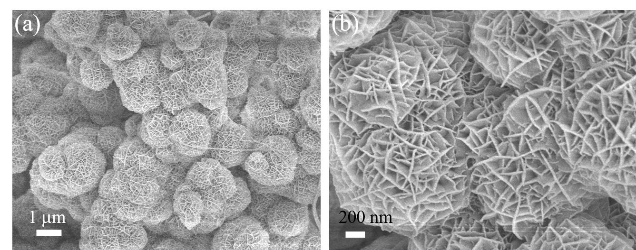

**Figure S1.** SEM images of NiMoO4/NF.

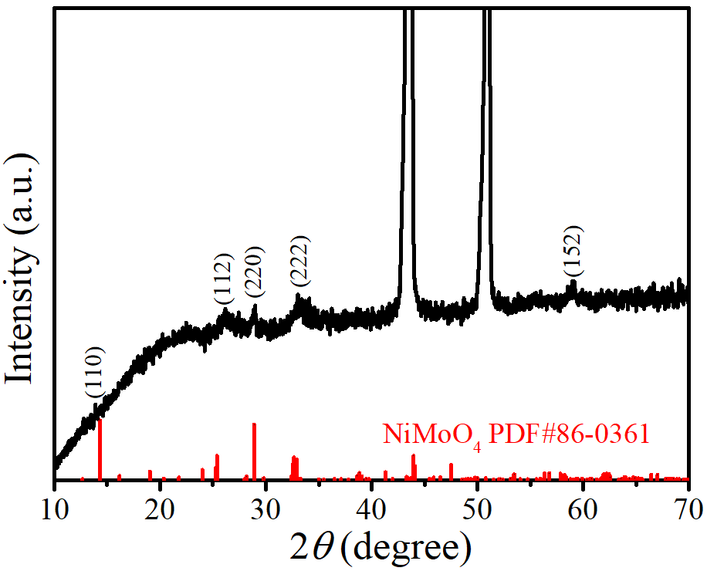

**Figure S2.** XRD pattern of NiMoO4/NF.

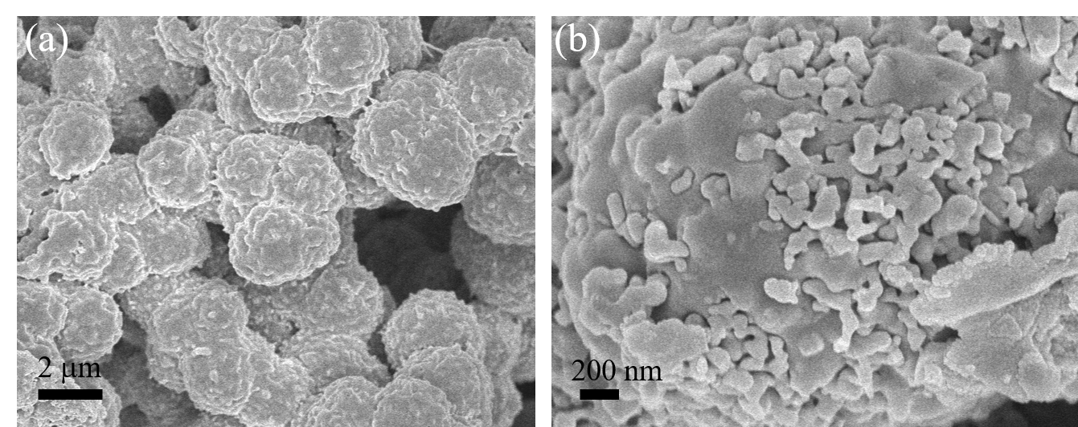

**Figure S3.** SEM images of Ni2P.

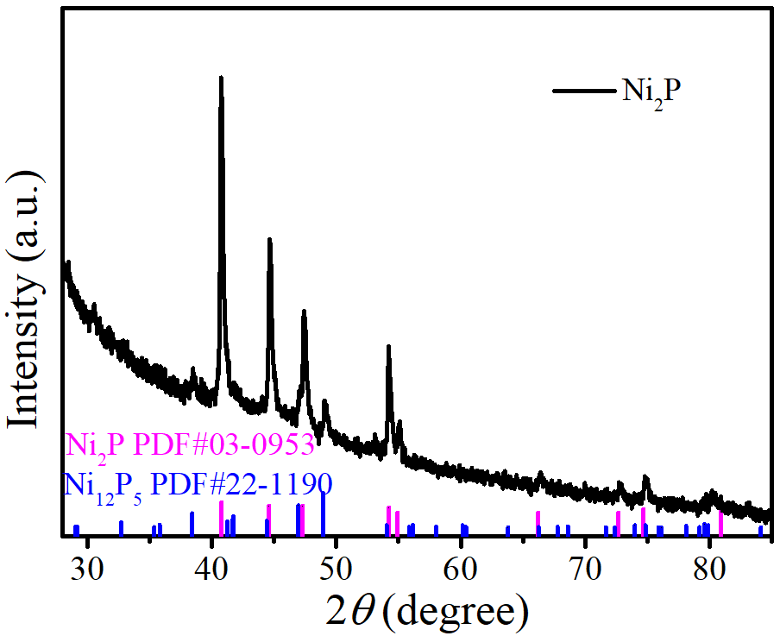

**Figure S4.** XRD pattern of Ni2P.

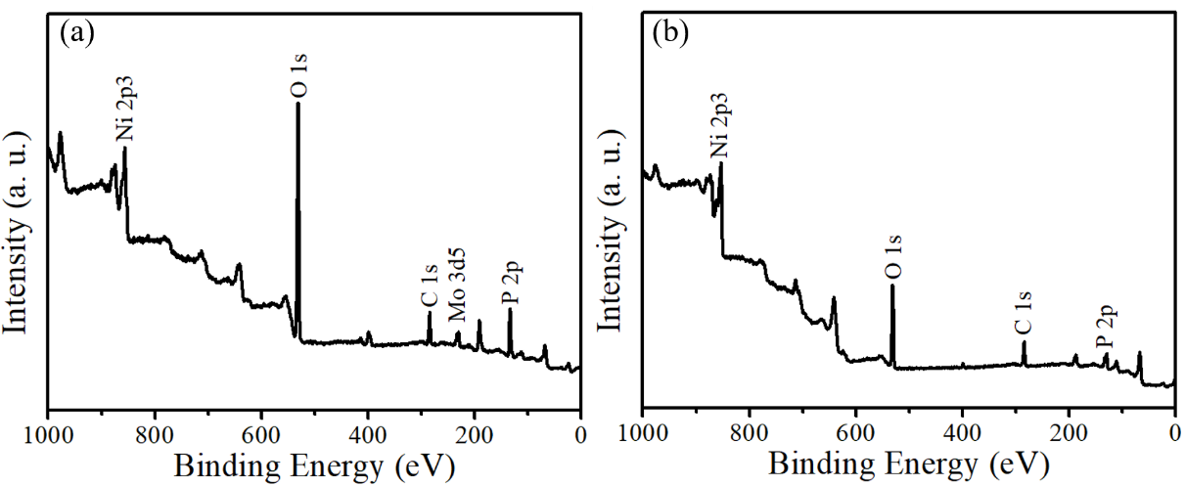

**Figure S5.** XPS survey spectra of (a) Ni2P/NiMoP and (b) Ni2P.

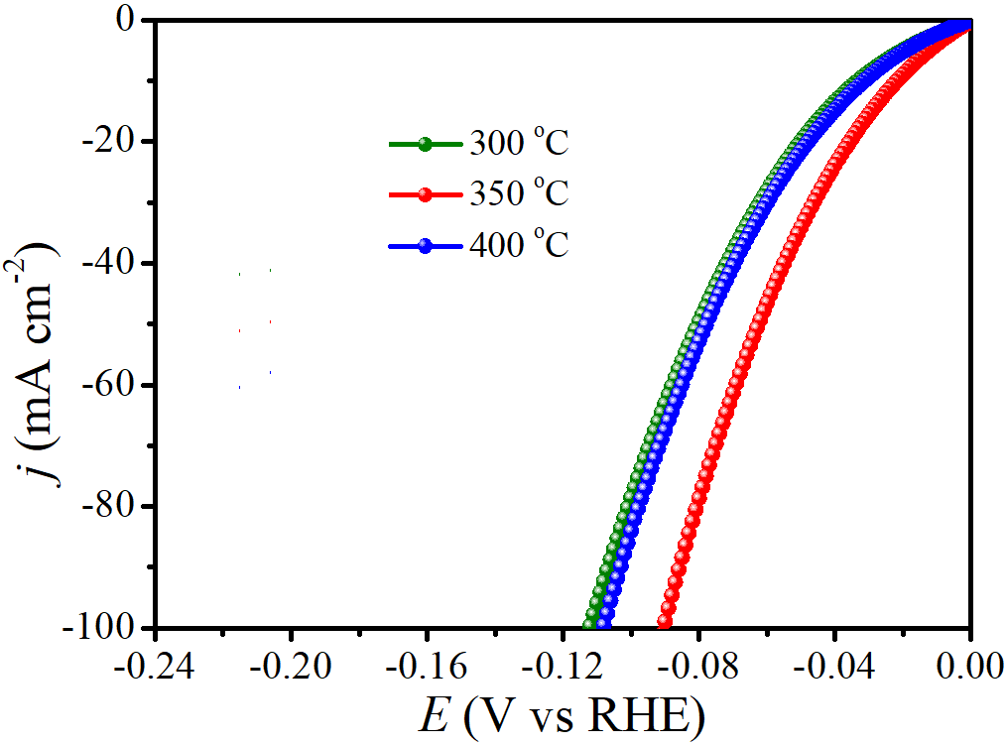

**Figure S6.** LSV curves of Ni2P/NiMoP annealed at different temperatures for HER.

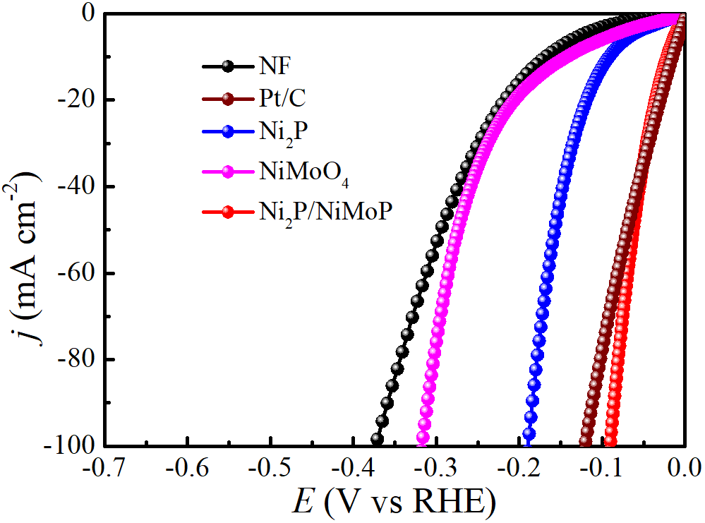

**Figure S7.** LSV curves of different catalysts for HER in 1.0 M KOH with a scan rate of 5 mV s-1.

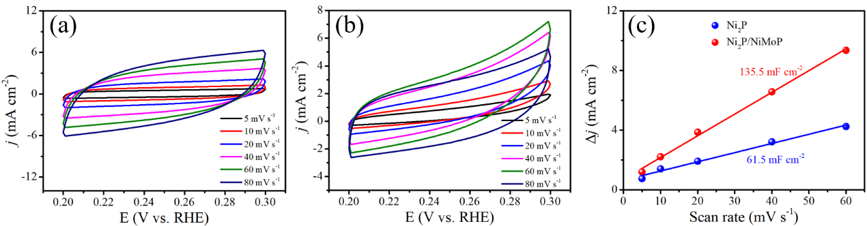

**Figure S8.** CV curves of (a) Ni2P/NiMoP and (b) Ni2P in the double layer capacitive region at the scan rates of from 5 mV to 80 mV s-1. (c) The calculated *C*dl of Ni2P/NiMoP and Ni2P.

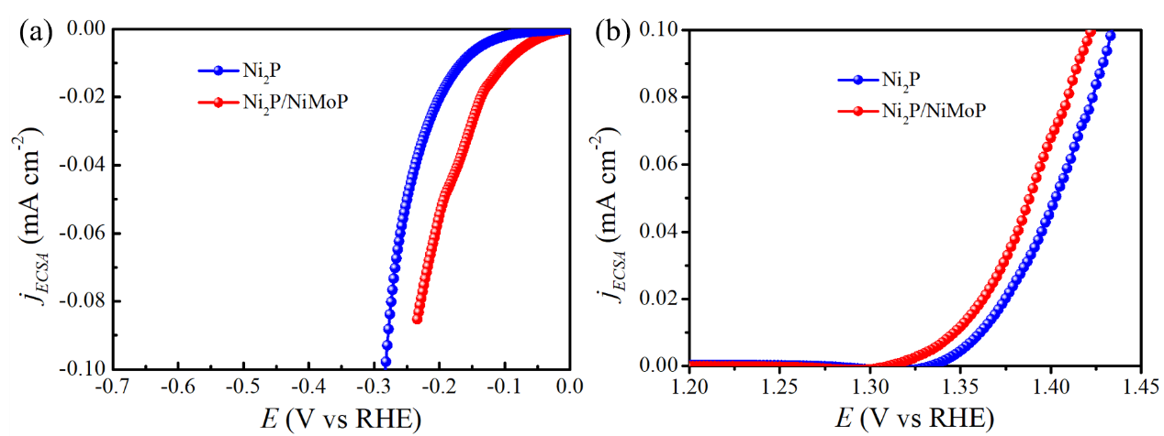

**Figure S9.** ECSA normalized LSV curves of Ni2P and Ni2P/NiMoP for (a) HER and (b) UOR.

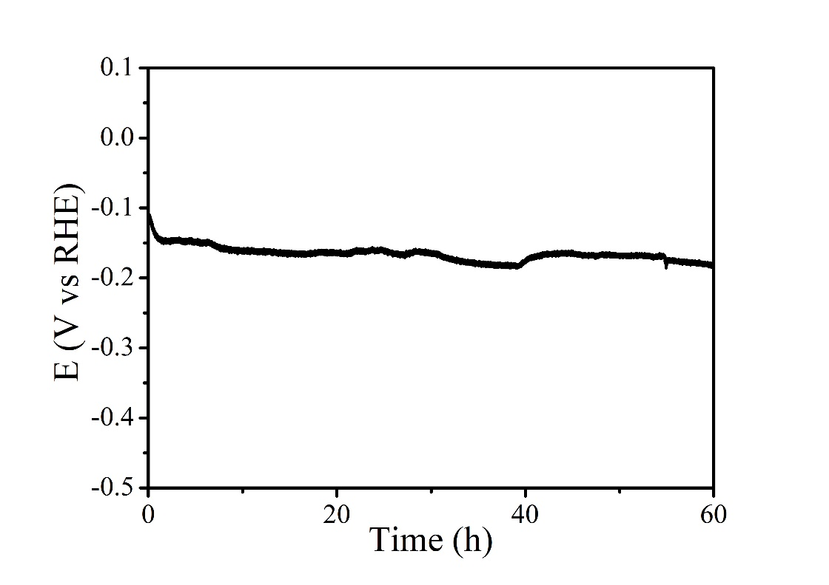

**Figure S10.** Chronoamperometric measurement of Ni2P/NiMoP at the current density of 100 mA cm-2 for HER.

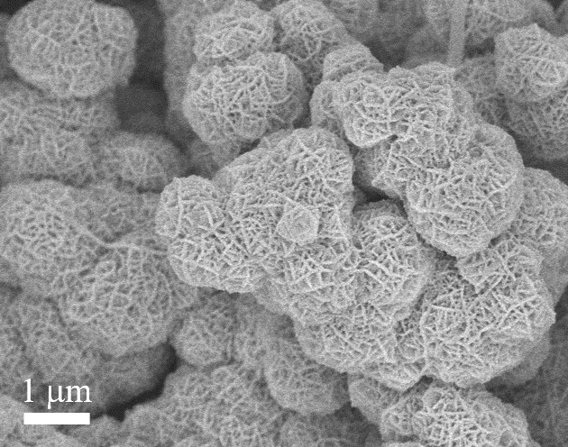

**Figure S11.** SEM image of Ni2P/NiMoP after HER test.

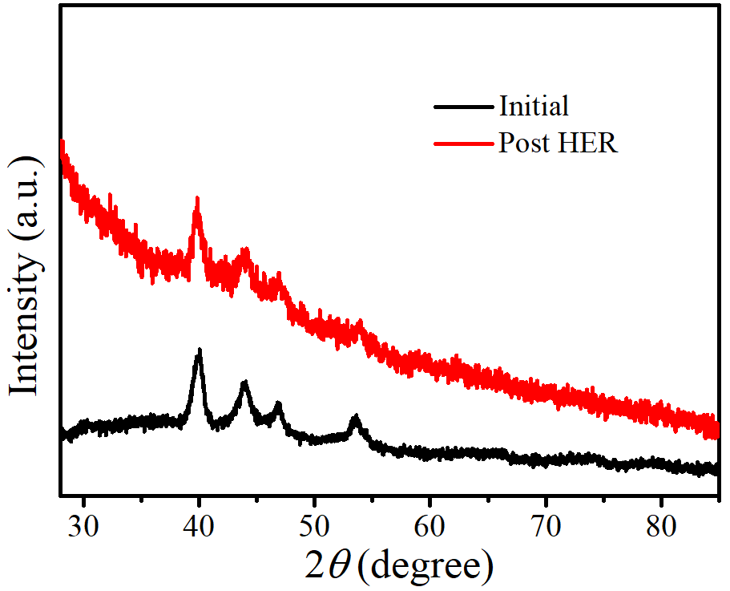

**Figure S12.** XRD pattern of Ni2P/NiMoP before and after HER test.

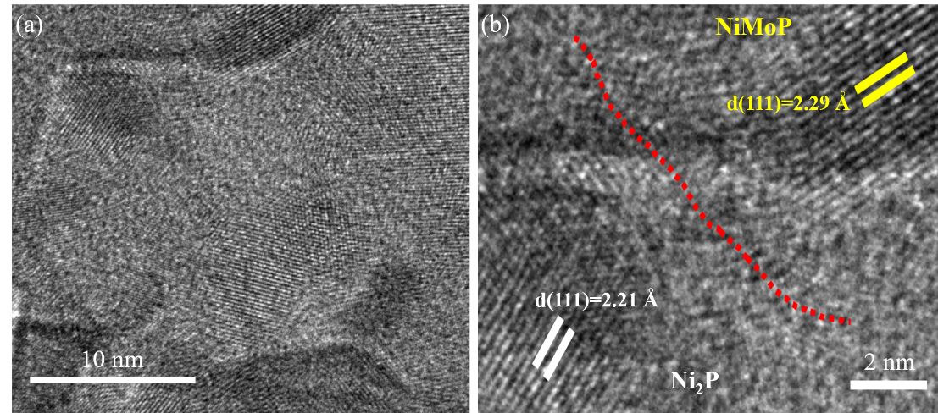

**Figure S13.** HRTEM images of Ni2P/NiMoP catalyst after HER durability test.

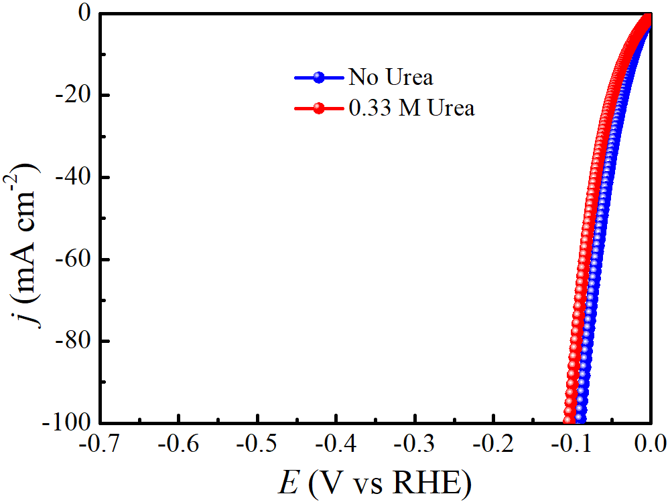

**Figure S14.** LSV curves of Ni2P/NiMoP with and without 0.33 M urea for HER.

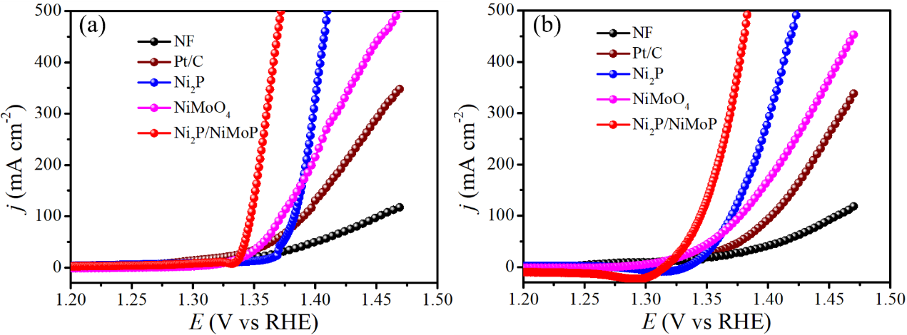

**Figure S15.** LSV curves of different catalysts for UOR in 1.0 M KOH with (a) positive scan and (b) negative scan.

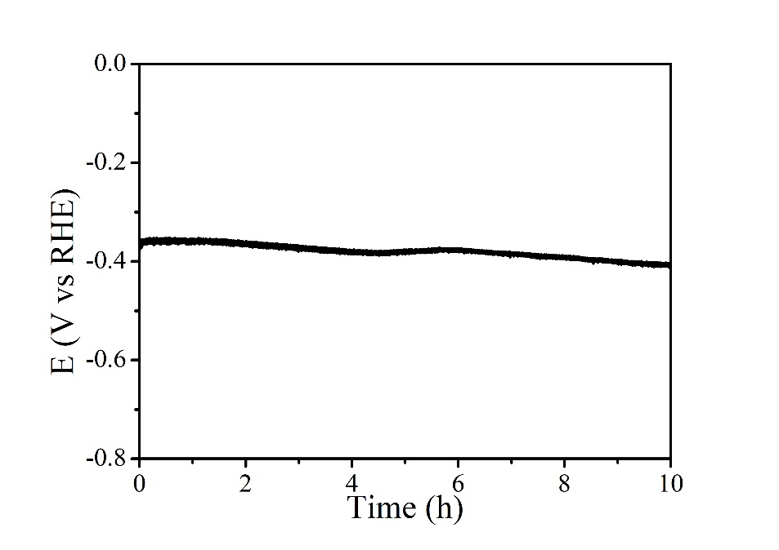

**Figure S16.** Chronoamperometric measurement of Ni2P/NiMoP at the current density of 500 mA cm-2 for HER without iR compensation.

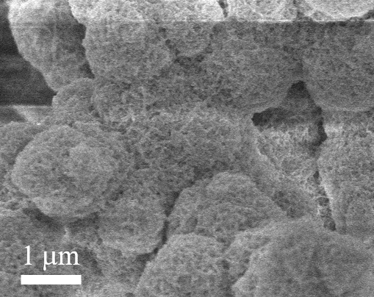

**Figure S17.** SEM image of Ni2P/NiMoP after UOR test.

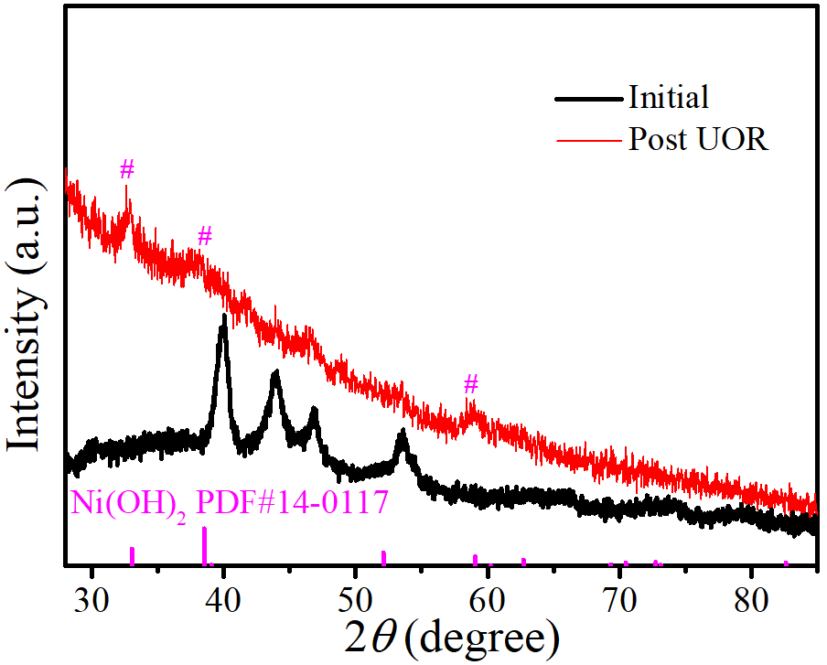

**Figure S18.** XRD pattern of Ni2P/NiMoP before and after UOR test.

F:\4-NiMo-P\TEM\反应后\2 20210415 1350 630.0 kx.tif

**Figure S19.** HRTEM image of Ni2P/NiMoP catalyst after UOR durability test.

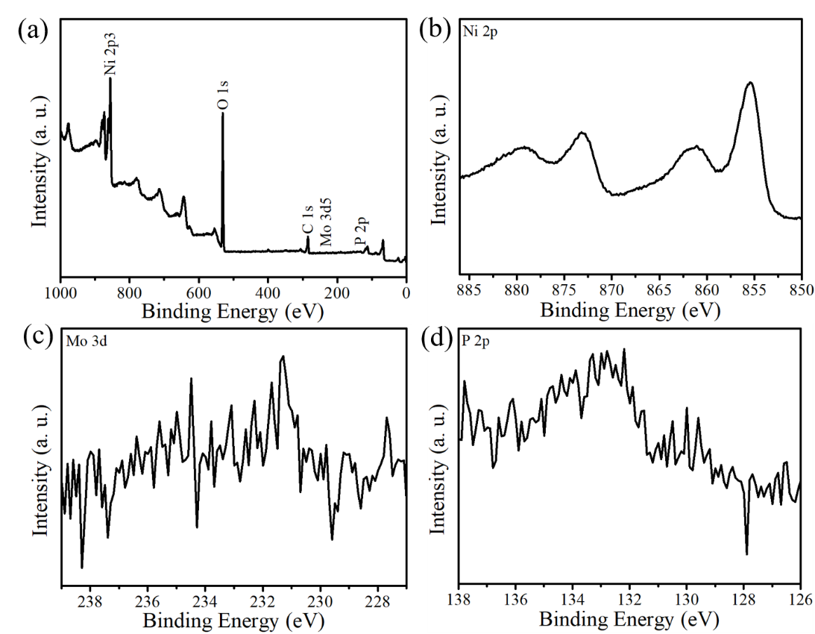

**Figure S20.** XPS spectra for Ni2P/NiMoP after UOR test: (a) XPS survey spectra, (b) Ni 2p, (c) Mo 3d and (d) P 2p.

**Table S1.** HER performance comparison of this work with report HER catalysts.

|  |  |  |  |
| --- | --- | --- | --- |
| Catalysts | Overpotentials at 10 mA cm-2 | Tafel slope (mV dec-1) | Reference |
| **Ni2P/NiMoP** | **22** | **34.5** | **This work** |
| Mo-CoP | 40 | 65 | *Nano Energy* **2018**, 48, 73-80 |
| Ru/Co3O4 | 30.96 | 69.75 | *Nano Energy* **2021**, 85, 105940 |
| FeNi3N | 75 | 98 | *Chem. Mater.* **2016**, 28, 6934 |
| MoN@NC | 62 | 54 | *ACS Catal.* **2017**, 7, 3540-3547 |
| CoP/CoMoP | 34 | 33 | *Nano Energy* **2020**, 68, 104332 |
| V-Co4N | 37 | 41 | *Angew. Chem. Int. Ed.* **2018**, 57, 5076 |
| Fe0.9Ni2.1S2@NF | 72 | 76 | *Adv. Energy Mater.* **2020**, 10, 2001963 |
| Ni3FeN | 158 | 42 | *Adv. Energy Mater.* **2016**, 6, 1502585 |
| CoP/NPC/TF | 80 | 50 | *Adv. Energy Mater.* **2019**, 9, 1803970 |
| CoNx/C | 133 | 57 | *Nat. Commun.* **2015**, 6,7992 |
| MoP/Mo2N | 89 | 78 | *Angew. Chem. Int. Ed.* **2021**, 60, 6673-6681 |
| Ni2(1-x)Mo2xP | 72 | 46.4 | *Nano Energy* **2018**, 53, 492-500 |

**Table S2.** The Rct and Rs of different samples at potential of -0.10 V for HER and 1.35 V for UOR. Rs related to the series resistance and Rct denotes the charge transfer resistance.

|  |  |  |  |  |
| --- | --- | --- | --- | --- |
| **Catalyst** | **Rs (Ω) in HER** | **Rct (Ω) in HER** | **Rs (Ω) in UOR** | **Rct (Ω) in UOR** |
| Ni2P/NiMoP | 2.1 | 1.6 | 2.3 | 3.9 |
| Ni foam | 2.3 | 104.2 | 2.5 | 100.9 |
| Ni2P | 2.4 | 16.4 | 2.4 | 8.6 |
| NiMoO4 | 2.3 | 45.9 | 2.4 | 10.8 |
| Pt/C | 2.3 | 0.7 | 2.9 | 49.9 |

**Table S3.** Comparison of the UOR performance of this work with recently reported catalysts.

|  |  |  |  |
| --- | --- | --- | --- |
| Catalysts | potential (V) at 100 mA cm-2 | Tafel slope (mV dec-1) | References |
| **Ni2P/NiMoP** | **1.37** | **23.3** | **This work** |
| CuO | 1.43 | 37 | *Chem. Commun.* **2019**, 55, 13562 |
| Ni-Mo alloy | 1.42 | 22 | *Nano Energy* **2019**, 60, 894-902 |
| Ni3N/Ni0.2Mo0.8N/NF | 1.366 | 89 | *Chem. Eng. J.* **2021**, 409, 128240 |
| Ni12P5/Ni-Pi/NF | 1.337 | 29 | *ACS Sustainable Chem. Eng.* **2020**, 8, 7463−7471 |
| CoMn/CoMn2O4 | 1.36 | 38 | *Adv. Funct. Mater.* **2020**, 30, 2000556 |
| Ni-WOx | 1.40 | 39 | *Angew. Chem. Int. Ed.* **2021**, 133, 10671-10676 |
| Ni2P NF/CC | 1.517 | 49 | *J. Mater. Chem. A* **2017**, 5, 3208-3213 |
| NFO | ~1.40 | 26.5 | *Chem. Commun.* **2019**, 55, 6555-6558 |
| NiFe(OH)2-SD/NF | ~1.39 | 41 | *J. Colloid Interf. Sci.* **2019**, 557, 10-17 |
| MnO2 | [1.33@ 10](mailto:1.33@%2010) mA cm-2 | 75 | *Angew. Chem. Int. Ed.* **2016**, 128, 3868-3872 |

**Table S4.** Performance comparison of reported two-electrode electrolyzer coupling anodic urea oxidation reactions and hydrogen production.

|  |  |  |  |
| --- | --- | --- | --- |
| Electrode Assembly | Anodic Oxidation Reaction | Potentials at 10 mA cm-2 | Reference |
| **Ni2P/NiMoP** | **Urea** | **1.35** **V** | **This work** |
| Ni-Mo nanotube | Urea | 1.43 V | *Nano Energy* **2019**, 60, 894-902 |
| Ni3N/Ni0.2Mo0.8N/NF | Urea | 1.348 V | *Chem. Eng. J.* **2021**, 409, 128240 |
| Ni(OH)2-NiMoOx/NF | Urea | 1.42 V | *Adv. Energy Mater.* **2019**, 9, 1902703 |
| NiMoO-Ar | Urea | 1.38 | *Energy Environ. Sci.* **2018**, 11, 1890 |
| Ni2P/Ni||Pt/C | Urea | 1.47 V | *Nano Research* **2021**, 14, 1405-1412 |
| NiCoP | Urea | 1.42 | *J. Mater. Chem. A* **2019**, 7, 9078 |
| NiFeRh-LDH | Urea | 1.344 | *Appl. Catal., B* **2021**, 284, 119740 |
| Zn0.08Co0.92P | Urea | 1.38 | *Adv. Energy Mater.* **2017**, 7, 1700020 |
| CoMn/CoMn2O4 | Urea | 1.51 | *Adv. Funct. Mater.* **2020**, 30, 2000556 |
| NiFeCo LDH | Urea | 1.49 | *Angew. Chem. Int. Ed.* **2016**, 55, 6702 |
| Ni-CoP | Urea | 1.43 | *Nano Energy* **2019**, 56, 411 |