Supplementary information

**Suppressed Recombination for Monolithic Inorganic Perovskite/Silicon Tandem Solar Cells with an Approximate Efficiency of 23%**

Sanlong Wang a,b,c,d,e,1, Pengyang Wang a,b,c,d,e,1,Bingbing Chen a,b,c,d,e, Renjie Li a,b,c,d,e, Ningyu Ren a,b,c,d,e, Yucheng Li a,b,c,d,e, Biao Shi a,b,c,d,e, Qian Huang a,b,c,d,e, Ying Zhao a,b,c,d,e, Michael Grätzel a,f, and Xiaodan Zhang a,b,c,d,e,*

*a Institute of Photoelectronic Thin Film Devices and Technology, Renewable Energy Conversion and Storage Center, Solar Energy Conversion Center, Nankai University, Tianjin 300350, PR China*

*b Key Laboratory of Photoelectronic Thin Film Devices and Technology of Tianjin, Tianjin 300350, PR China*

*c Haihe Laboratory of Sustainable Chemical Transformations, Tianjin 300192, PR China*

*d Engineering Research Center of Thin Film Photoelectronic Technology of Ministry of Education, Tianjin 300350, PR China*

*e Collaborative Innovation Center of Chemical Science and Engineering (Tianjin), Tianjin 300072, PR China*

*f Laboratory of Photonics and Interfaces, Ecole Polytechnique Federale de Lausanne, Lausanne 1015, Switzerland*

*Corresponding author.

*E-mail addresses:* [xdzhang@nankai.edu.cn](mailto:xdzhang@nankai.edu.cn) (X. Zhang)

1 S.L. Wang and P.Y. Wang contributed equally to this work.

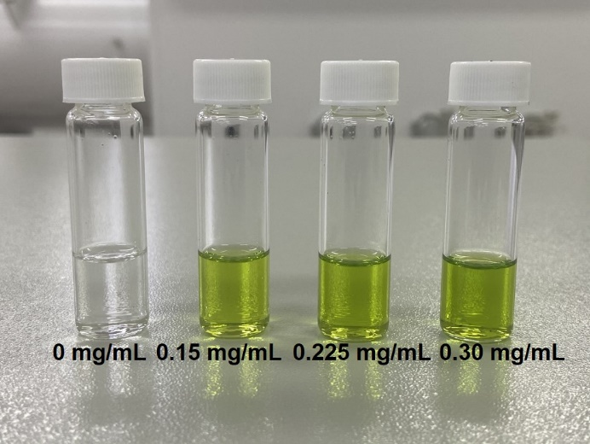

**Fig. S1**. Image of various concentrations of NiI2 solution.

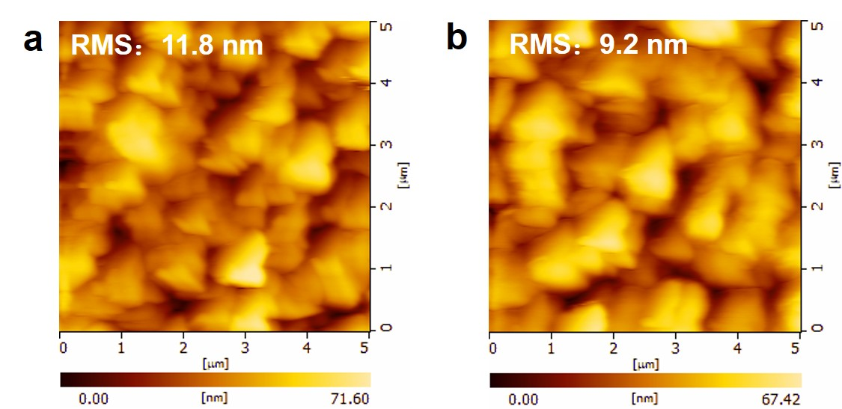

**Fig. S2**. Atomic force microscopy (AFM) images of CsPbIxBr3-x perovskite films without (a) and with NiI2 (b) treatment. The root means square (RMS) is 11.8 nm and 9.2 nm, respectively.

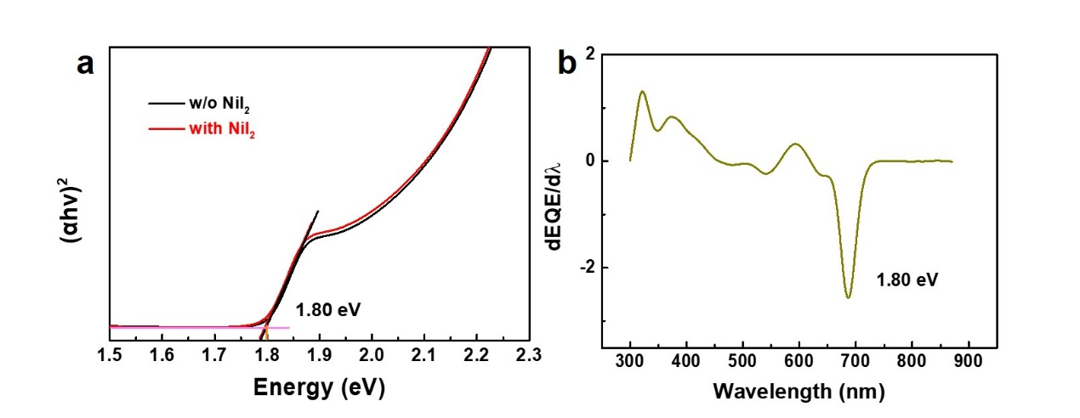

**Fig. S3**. The optical band gap of CsPbIxBr3-x perovskite. (a) The relationship of (αhv)2 vs. energy derived from UV-Vis, the bandgap of CsPbIxBr3-x perovskite film without and with NiI2 treatment shows a bandgap of 1.80 eV. (b) The EQE differential of the NiI2 treated PSCs.

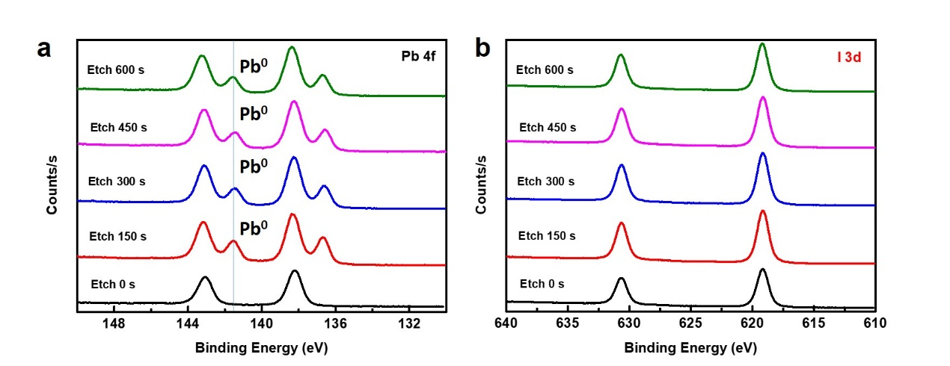

**Fig. S4** (a) The Pb 4f and (b) I 3d core level spectra of perovskite films etched with different times (0 s, 150 s, 300 s, 450 s and 600 s).

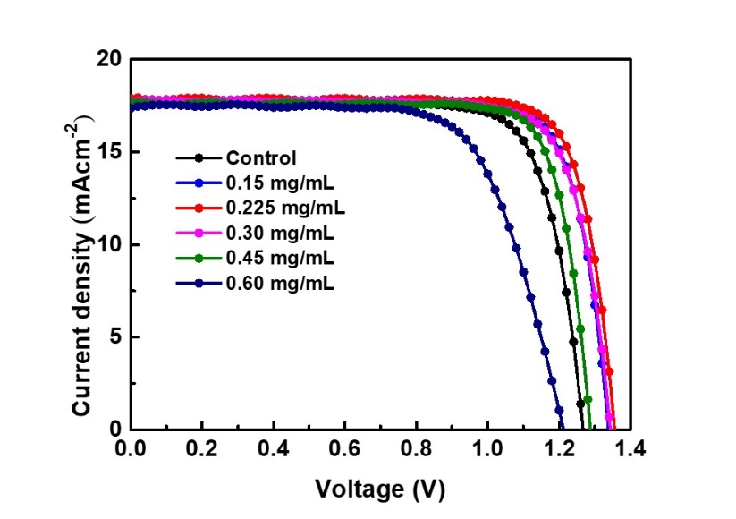

**Fig. S5**. J-V characteristics of CsPbIxBr3-x PSCs treated with various concentrations of NiI2, the PCE of corresponding PSCs are 17.49%, 19.06%, 19.53%, 18.82%, 18.40% and 14.78% for control, treated with NiI2 of 0.15 mg/mL, 0.225 mg/mL, 0.30 mg/mL, 0.45 mg/mL and 0.6 mg/mL, respectively.

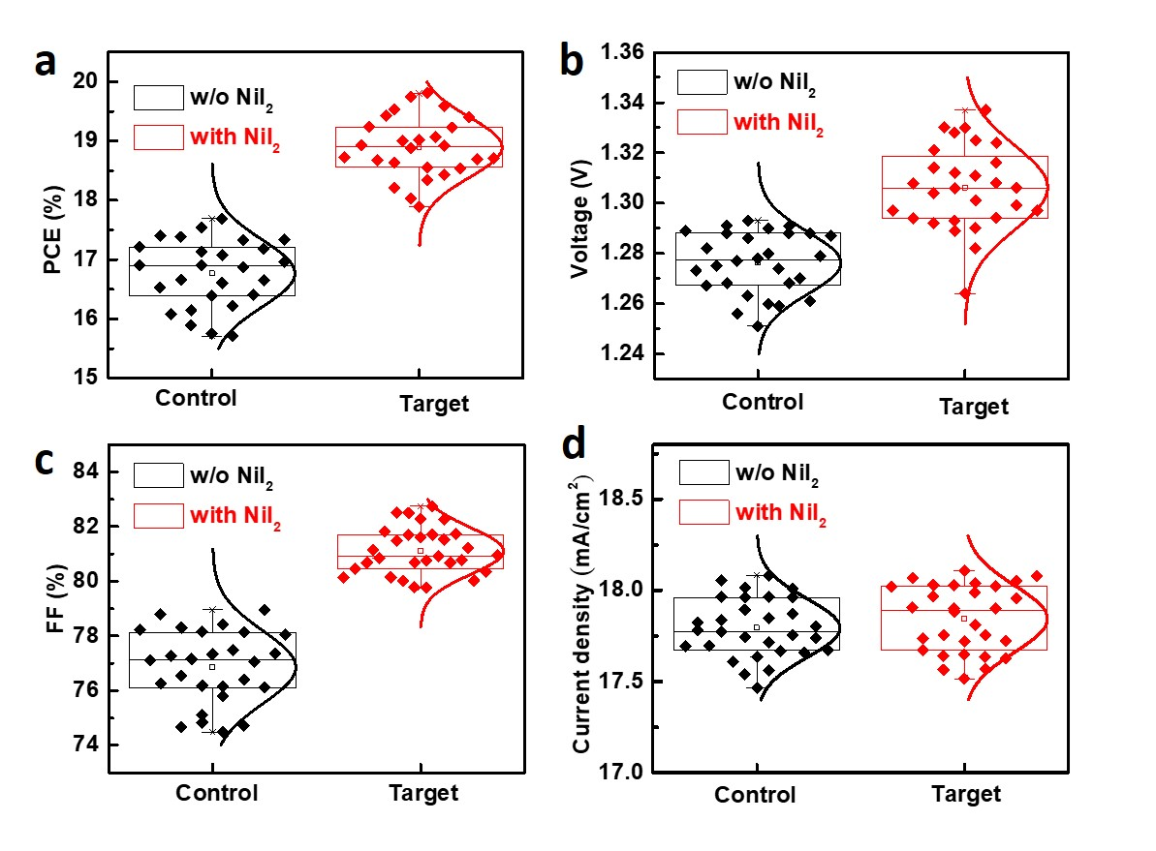

**Fig. S6**. Photovoltaic parameters of PCE, *VOC*, FF and *JSC* distributions of PSCs obtained from control CsPbIxBr3-x PSCs and NiI2 (0.225 mg/mL) treated CsPbIxBr3-x PSCs, respectively.

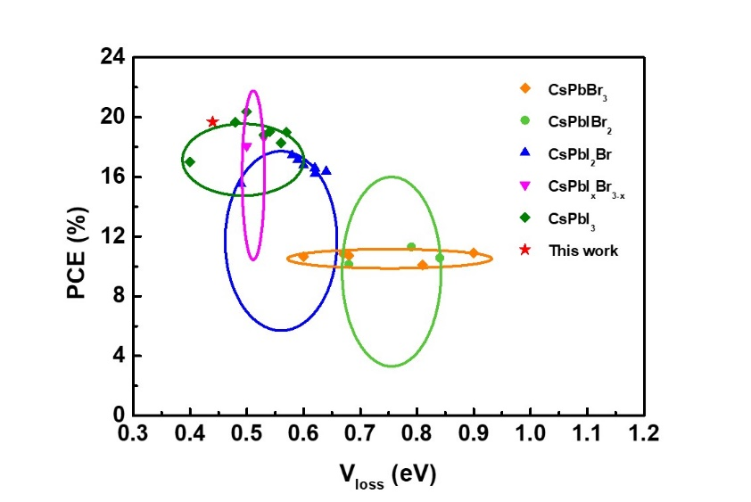

**Fig. S7**. Plots of PCE against voltage loss of inorganic PSCs are reported in this work and previous research from Table S4.

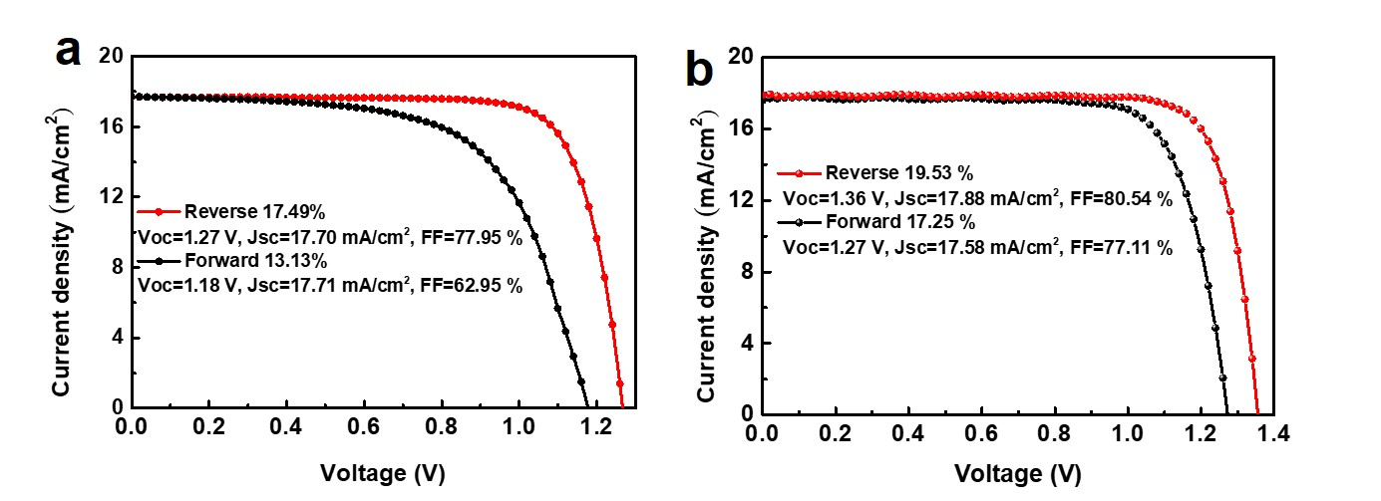

**Fig. S8**. J-V hysteresis characteristics of CsPbIxBr3-x PSCs without (a) and with (b) NiI2 treatment.

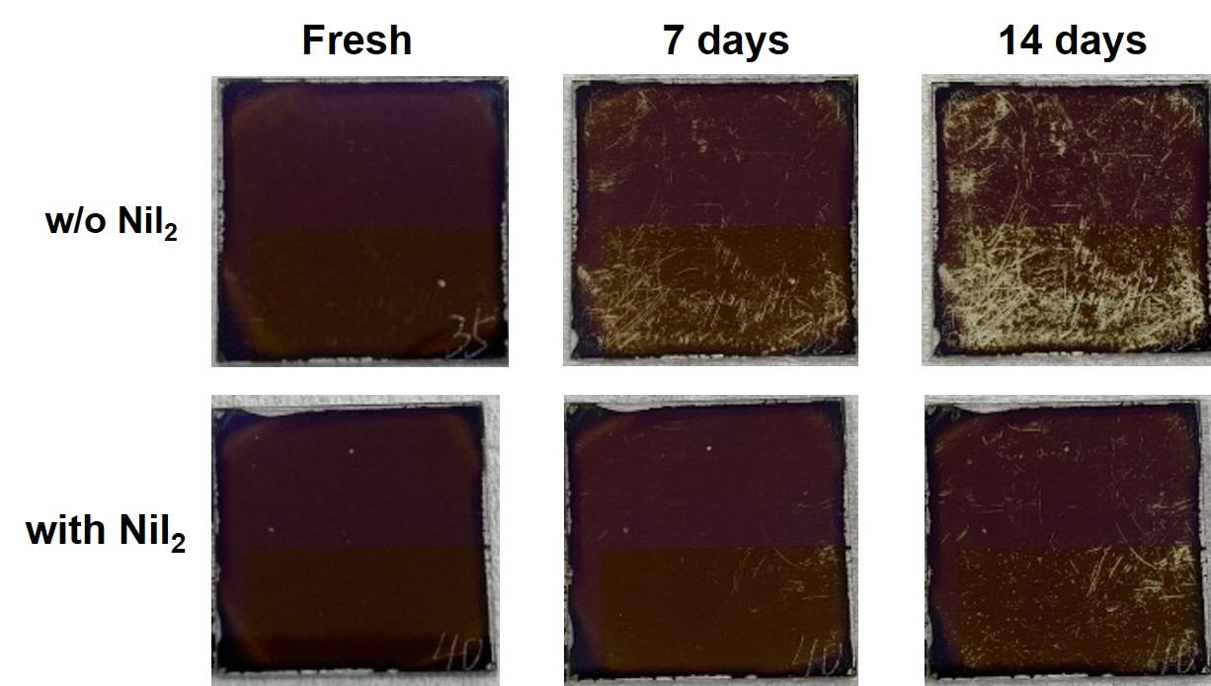

**Fig. S9**. Images of CsPbIxBr3-x film and NiI2 treated CsPbIxBr3-x film placed in ambient air (Temperature: 25 oC, RH about 20%) for various time.

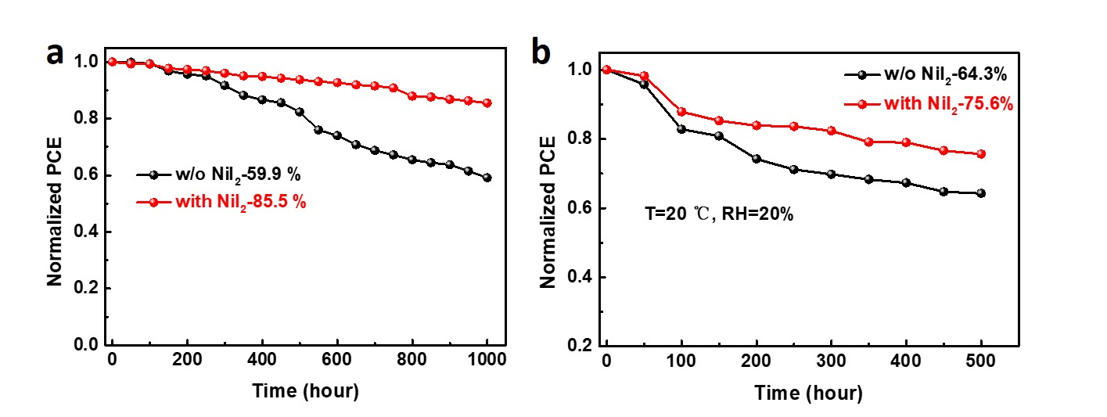

**Fig. S10**. Normalized PCE of control and NiI2 treated PSCs stored in N2 atmosphere (a) and ambient air (RH about 20%) (b) for 1000 h and 500 h, respectively.

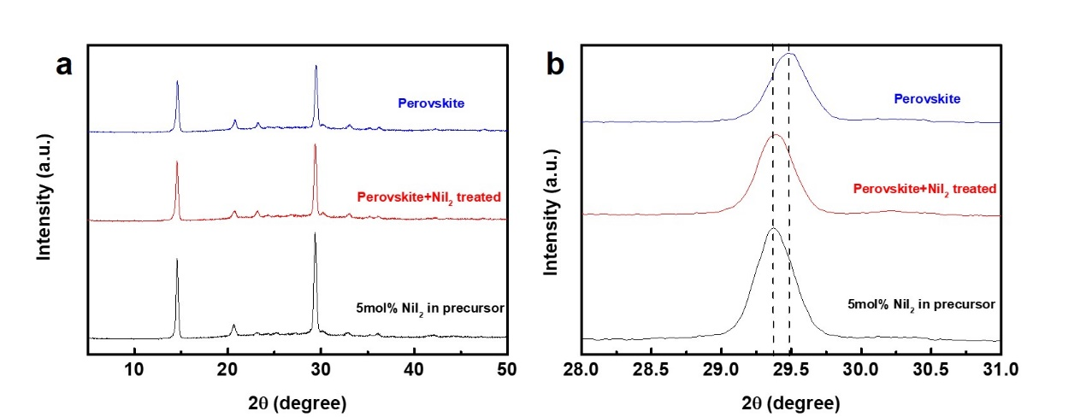

**Fig. S11** The XRD patterns of perovskite film without and with NiI2 surface treatment, incorporated with 5% NiI2 in precursor, respectively.

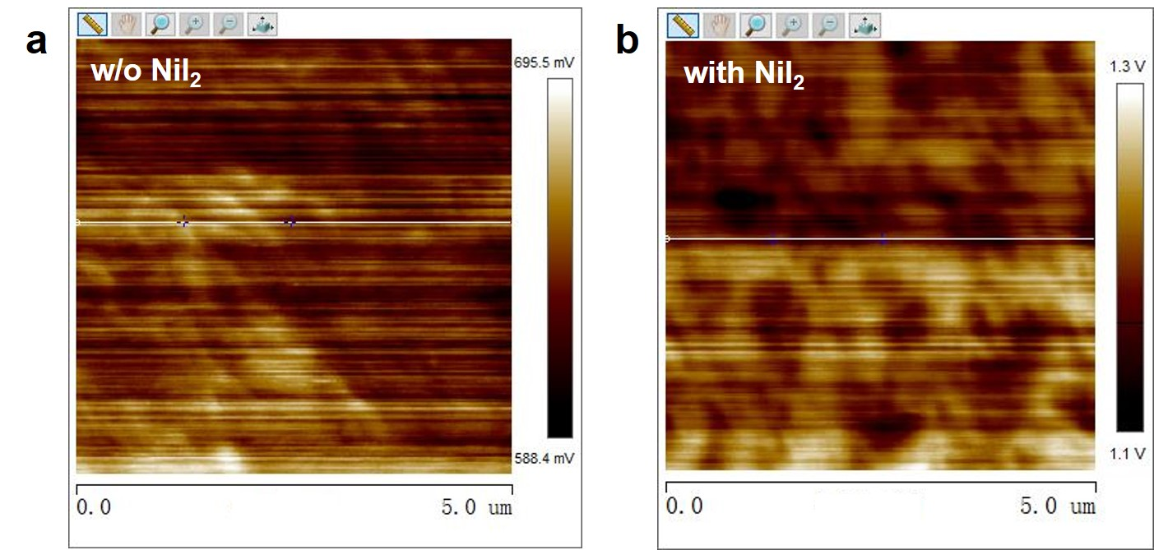

**Fig. S12**. Kelvin probe force microscopy (KPFM) surface potential spectra of CsPbIxBr3-x films without (a) and with (b) NiI2 treatment.

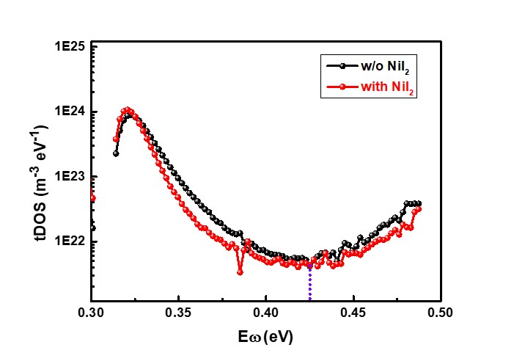

**Fig. S13** The trap density of states (tDOS) of the perovskite devices with and without NiI2 treatment.

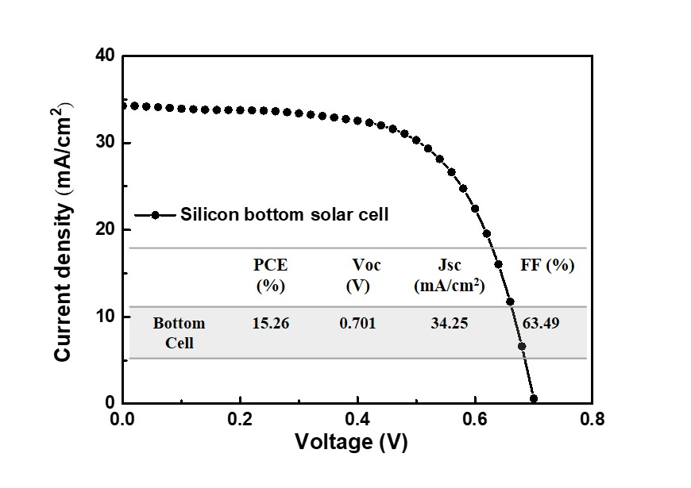

**Fig. S14** The J-V curve of silicon solar cell.

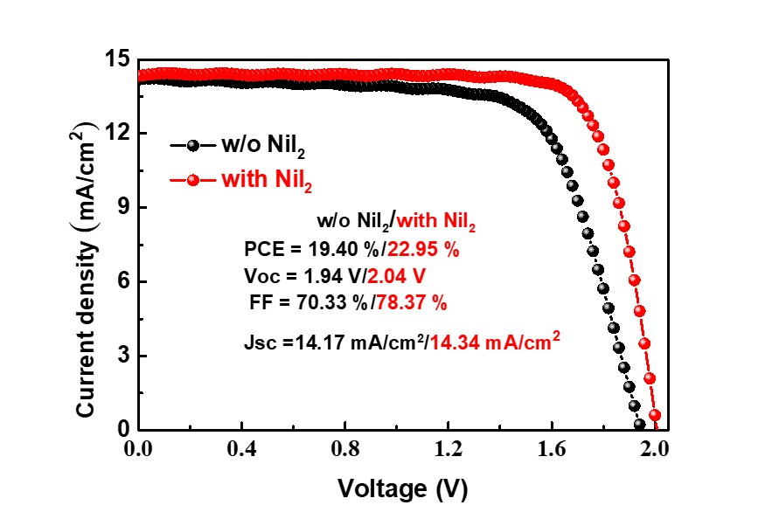

**Fig. S15** *J-V* curves of the champion CsPbIxBr3-x/silicon tandem solar cells without and with NiI2 treatment.

**Table S1**. Summary of detailed performance parameters of CsPbIxBr3-x inorganic PSCs.

|  |  |  |  |  |  |
| --- | --- | --- | --- | --- | --- |
| Recorded solar cell | Eff. [%] | VOC [V] | Eg [eV] | Eloss [eV] | Ref |
| CsPbBr3 | 10.65 | 1.700 | 2.30 | 0.60 | [1] |
| CsPbBr3 | 10.1 | 1.590 | 2.30 | 0.81 | [2] |
| CsPbBr3 | 10.91 | 1.498 | 2.30 | 0.90 | [3] |
| CsPbBr3 | 10.85 | 1.626 | 2.30 | 0.67 | [4] |
| CsPbIBr2 | 10.13 | 1.370 | 2.05 | 0.68 | [5] |
| CsPbI2Br | 17.45 | 1.334 | 1.92 | 0.58 | [6] |
| CsPbI2Br | 16.60 | 1.300 | 1.92 | 0.62 | [7] |
| CsPbI2Br | 16.79 | 1.320 | 1.92 | 0.60 | [8] |
| Cs0.99Rb0.01PbI2Br | 17.16 | 1.320 | 1.91 | 0.59 | [9] |
| CsPbI3-xBrx | 18.64 | 1.234 | 1.77 | 0.53 | [10] |
| CsPbI3-xBrx | 18.06 | 1.270 | 1.77 | 0.50 | [11] |
| CsPbI2.5Br0.5 | 17.10 | 1.250 | 1.83 | 0.58 | [12] |
| CsPbI3-xBrx | 17.03 | 1.090 | 1.71 | 0.62 | [13] |
| CsPbI2.85I0.15 | 19.65 | 1.230 | 1.71 | 0.48 | [14] |
| CsPbI3-xBrx | 19.53 | 1.36 | 1.80 | 0.44 | This work |

**Table S2**. The TRPL parameters of CsPbIxBr3-x perovskite films without and with NiI2 treatment.

|  |  |  |  |  |  |
| --- | --- | --- | --- | --- | --- |
| Type | A1 (%) | τ1 (ns) | A2 (%) | τ2 (ns) | τave (ns) |
| Control | 2.51 | 4.99 | 97.49 | 18.94 | 18.59 |
| Target | 1.06 | 6.35 | 98.94 | 28.99 | 28.75 |

**Table S3** Devices performance parameters of opaque single-junction IPSCs, semitransparent IPSCs and two-terminal IPVK/Si tandem solar cell.

|  |  |  |  |  |
| --- | --- | --- | --- | --- |
| Type | PCE  (%) | VOC (V) | Jsc  (mA/cm2) | FF (%) |
| Opaque single junction | 19.53 | 1.36 | 17.88 | 80.54 |
| Semitransparent IPSCs | 14.41 | 1.300 | 14.68 | 75.53 |
| Two-terminal tandem solar cells | 22.95 | 2.04 | 14.36 | 78.37 |

**References**

[1] Q. Zhou, J. Duan, X. Yang, Y. Duan, Q. Tang, Interfacial Strain Release from the WS2/CsPbBr3 van der Waals Heterostructure for 1.7 V Voltage All-Inorganic Perovskite Solar Cells, Angew. Chem. Int. Ed. 132 (2020) 22181-22185.

[2] J. Duan, Y. Zhao, X. Yang, Y. Wang, B. He, Q. Tang, Lanthanide Ions Doped CsPbBr3 Halides for HTM-Free 10.14%-Efficiency Inorganic Perovskite Solar Cell with an Ultrahigh Open‐Circuit Voltage of 1.594 V, Adv. Energy Mater. 8 (2018) 1802346.

[3] G. Tong, T. Chen, H. Li, L. Qiu, Z. Liu, Y. Dang, W. Song, L. K. Ono, Y. Jiang, Y. Qi, Phase transition induced recrystallization and low surface potential barrier leading to 10.91%-efficient CsPbBr3 perovskite solar cells, Nano Energy 65 (2019) 104015.

[4] J. Duan, Y. Wang, X. Yang, Q. Tang, Alkyl-Chain-Regulated Charge Transfer in Fluorescent Inorganic CsPbBr3 Perovskite Solar Cells, Angew. Chem. Int. Ed. 59 (2020) 4391-4395.

[5] S. Yang, Z. Guo, L. Gao, F. Yu, C. Zhang, M. Fan, G. Wei, T. Ma, Bifunctional Dye Molecule in All-Inorganic CsPbIBr2 Perovskite Solar Cells with Efficiency Exceeding 10%, Sol. RRL 3 (2019) 1900212.

[6] S. S. Mali, J. V. Patil, P. S. Shinde, G. de Miguel, C. K. Hong, Fully air-processed dynamic hot-air-assisted M: CsPbI2Br (M: Eu2+, In3+) for stable inorganic perovskite solar cells, Matter 4 (2021) 635-653.

[7] Y.-X. Luo, J. Chen, H.-Y. Hou, Y.-C. Ye, K.-C. Shen, L. Lu, Y. Li, F. Song, X. Gao, J.-X. Tang, Hierarchically Manipulated Charge Recombination for Mitigating Energy Loss in CsPbI2Br Solar Cells, ACS Appl. Mater. Interfaces 12 (2020) 41596-41604.

[8] Y. Han, H. Zhao, C. Duan, S. Yang, Z. Yang, Z. Liu, S. Liu, Controlled n‐Doping in Air‐Stable CsPbI2Br Perovskite Solar Cells with a Record Efficiency of 16.79%, Adv. Funct. Mater. 30 (2020) 1909972.

[9] S. S. Mali, J. V. Patil, C. K. Hong, Making air-stable all-inorganic perovskite solar cells through dynamic hot-air, Nano Today 33 (2020) 100880.

[10] Q. Ye, Y. Zhao, S. Mu, F. Ma, F. Gao, Z. Chu, Z. Yin, P. Gao, X. Zhang, J. You, Cesium Lead Inorganic Solar Cell with Efficiency beyond 18% via Reduced Charge Recombination, Adv. Mater. 31 (2019) 1905143.

[11] Y. Zheng, X. Yang, R. Su, P. Wu, Q. Gong, R. Zhu, High‐Performance CsPbIxBr3-x All-Inorganic Perovskite Solar Cells with Efficiency over 18% via Spontaneous Interfacial Manipulation, Adv. Funct. Mater. 30 (2020) 2000457.

[12] J. Tian, J. Wang, Q. Xue, T. Niu, L. Yan, Z. Zhu, N. Li, C. J. Brabec, H. L. Yip, Y. Cao, Composition engineering of all-inorganic perovskite film for efficient and operationally stable solar cells, Adv. Funct. Mater. 30 (2020) 2001764.

[13] Z. Yao, Z. Jin, X. Zhang, Q. Wang, H. Zhang, Z. Xu, L. Ding, S. F. Liu, Pseudohalide (SCN−)-doped CsPbI3 for high-performance solar cells, J. Mater. Chem. C 7 (2019) 13736-13742.

[14] K. Wang, C. Gao, Z. Xu, Q. Tian, X. Gu, L. Zhang, S. Zhang, K. Zhao, S. Liu, In-Situ Hot Oxygen Cleansing and Passivation for All-Inorganic Perovskite Solar Cells Deposited in Ambient to Breakthrough 19% Efficiency, Adv. Funct. Mater. 31 (2021) 2101568.