**Ⅰ. Supporting Figures**



**Figure S1.** Peak current of different kinetic promoters according to the CV profiles in Figure 2a. Higher peak current indicates faster liquid–liquid conversion kinetics in a working battery.



**Figure S2.** EIS of Li2S6 symmetric cells with different kinetic promoters.



**Figure S3.** Peak time corresponding to the chronoamperometry curves in Figure 2b. Shorter time to reach the current peak indicates accelerated liquid–solid conversion kinetics in a working battery.



**Figure S4.** Onset potential determined from the LSV profiles in Figure 2c. The onset potential was defined as the voltage versus Li/Li+ when the current reaches 0.1 mA. The lower potential indicates faster solid–liquid conversion kinetics.



**Figure S5.** Cyclic voltammetry profiles of Li | organodiselenide cells with Me-Se, Ph-Se, or mixed-Se catholyte.



**Figure S6.** Cycling performance of Li | organodiselenide cells with Me-Se, Ph-Se, or mixed-Se catholyte. The specific capacity was calculated based on a sulfur loading of 1.2 mgS cm−2.

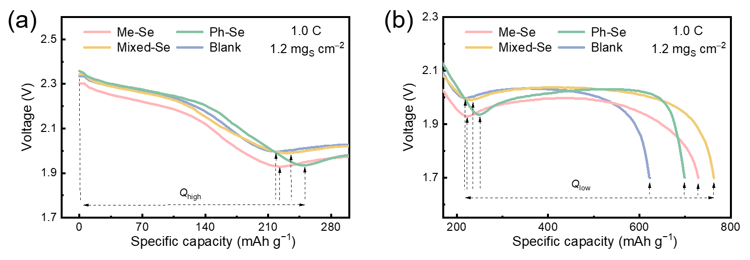

**Figure S7.** Amplified discharge profiles corresponding to Figure 3b for the partition of *Q*high and *Q*low. The points at which the slope equals to zero are assigned as the demarcations for high discharge plateau and low discharge plateau for quantitative capacity analysis.



**Figure S8.** Capacity retention of Li–S coin cells after 200 cycles at the current density of 0.5 C with a sulfur loading of 1.2 mgS cm‒2.

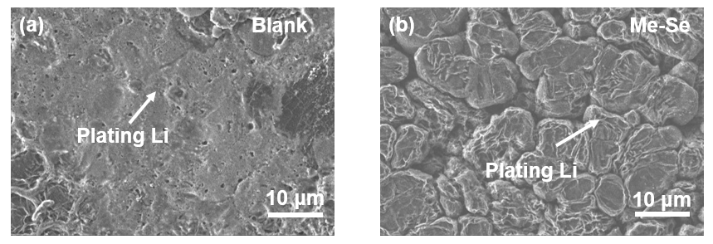

**Figure S9.** SEM images of Li anodes in Li–S coin cells (a) without and (b) with Me-Se after 5 cycles.

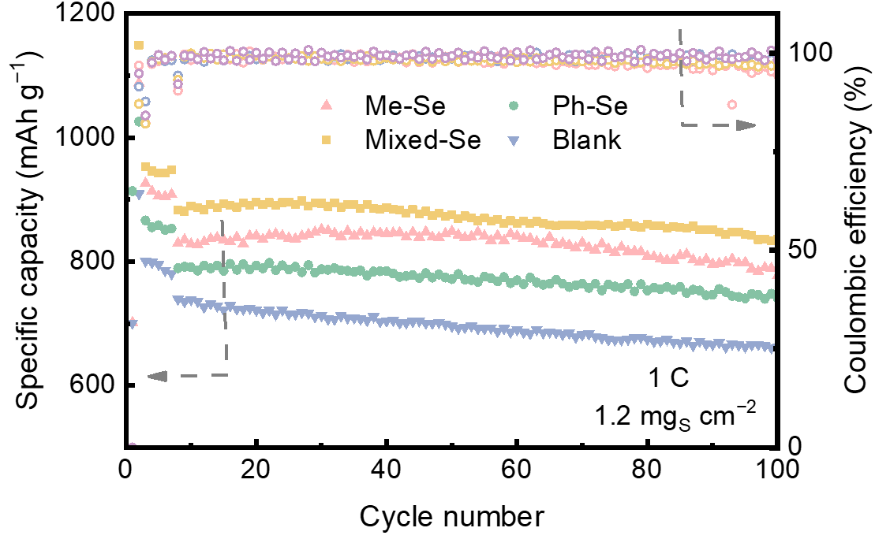

**Figure S10.** Cycling performance of Li–S cells with mixed-Se, Ph-Se, Me-Se, and blank electrolyte at 1 C.



**Figure S11.** Galvanostatic discharge–charge profiles of the 1st cycle in 300 Wh kg−1 level pouch cells at 0.05 C with a sulfur loading of 4.9 mgS cm‒2 and an E/S ratio of 4.0 μL mgS‒1.



**Figure S12.** Galvanostatic discharge–charge profiles of the 1st cycle in 400 Wh kg−1 level pouch cells at 0.025 C with a sulfur loading of 6.1 mgS cm‒2 and an E/S ratio of 3.0 μL mgS‒1.

**Ⅱ. Supporting Tables**

**Table S1.** Simulated resistance of Li2S6 symmetric cells with Me-Se, Ph-Se, or blank electrolyte based on the EIS results.

|  |  |  |
| --- | --- | --- |
|  | *R*l (Ω) | *R*ct (Ω) |
| Me-Se | 9.5 | 23.5 |
| Ph-Se | 2.9 | 14.0 |
| blank | 5.9 | 42.7 |