Supporting Information

**Stable Ni-rich Layered Oxide Cathode for Sulfide All-Solid-State Lithium Battery**

*Yue Wang,1-5 Zhixuan Wang,1-4 Dengxu Wu, 1-4 Quanhai Niu, 1 Pushun Lu, 1-4 Tenghuan Ma,1-5 Yibo Su6, Liquan Chen,1-4 Hong Li,1-5 and Fan Wu1-5\**

1Tianmu Lake Institute of Advanced Energy Storage Technologies, Liyang 213300, Jiangsu, China;

2Yangtze River Delta Physics Research Center, Liyang 213300, Jiangsu, China;

3Key Laboratory for Renewable Energy, Beijing Key Laboratory for New Energy Materials and Devices,

Beijing National Laboratory for Condensed Matter Physics, Institute of Physics, Chinese Academy of

Sciences, Beijing, 100190, China;

4University of Chinese Academy of Sciences, Beijing, 100049, China

5Nano Science and Technology Institute, University of Science and Technology of China, Suzhou 215123,

China

6Science and Technology Research Institute China Three Gorges Corporation Beijing, China

*Corresponding author: fwu@iphy.ac.cn

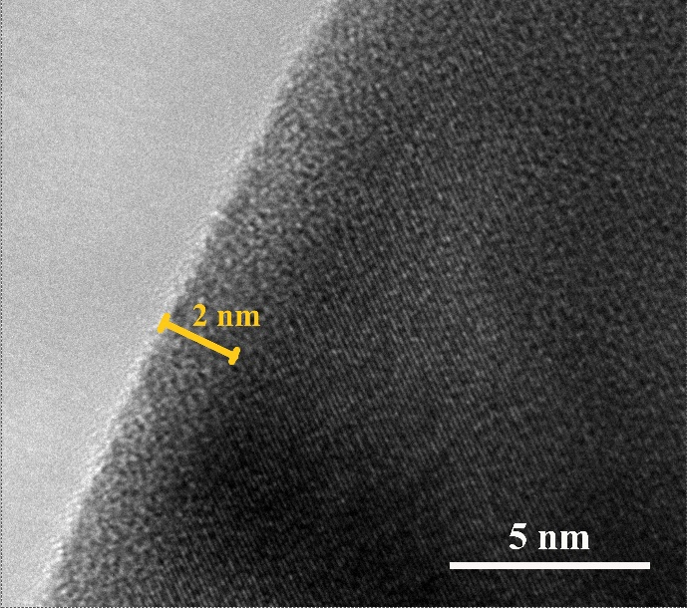

**Fig. S1.** TEM image of NCM88-S sample.

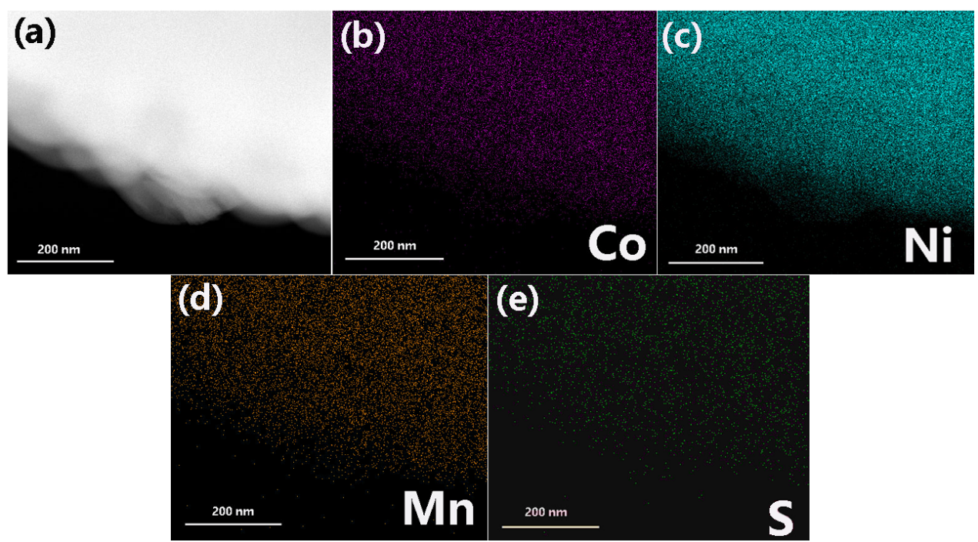

**Fig. S2.** TEM-EDX elemental mappings of NCM88-S powder corresponding to (b) Co, (c) Ni, (d) Mn, and (e) S.

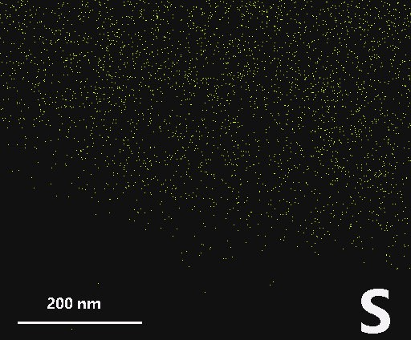

**Fig. S3.** TEM-EDX of Sulfur in NCM88-S sample.

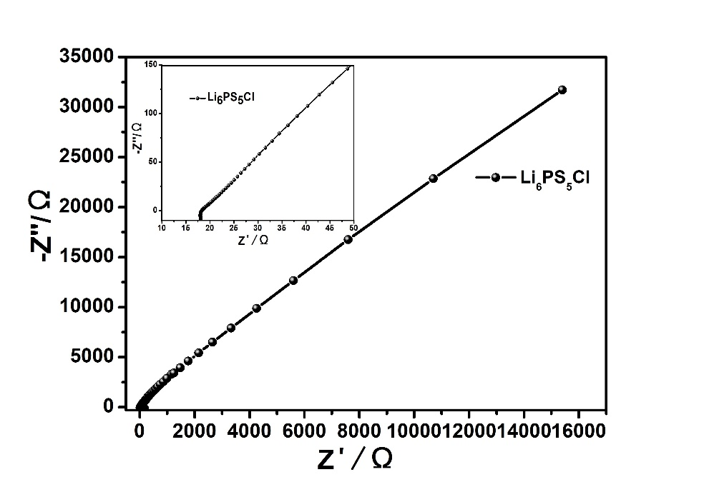

**Fig. S4.** Nyquist of plot of the Li6PS5Cl solid state electrolyte (80 mg) without attaching the battery electrodes.

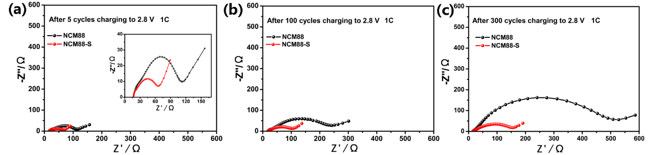

**Fig. S5.** Nyquist plots of sulfide-based ASSLIBs using NCM88 cathode and NCM88-S cathode after (a) 5 cycles, (b)100 cycles, and (c)300 cycles.

**Table S1.** RSE, RSE/CAM, and RCell values of NCM88 and NCM88-S cathodes after 5 cycles, 100 cycles and 300 cycles.

|  |  |  |  |
| --- | --- | --- | --- |
|  | Cycle | NCM88（Ω） | NCM88-S（Ω） |
| RSE | 5 | 17.7 | 17.1 |
| 100 | 18.8 | 18.9 |
| 300 | 19.7 | 19.7 |
| RSE/CAM | 5 | 48.7 | 96.9 |
| 100 | 82.2 | 220.1 |
| 300 | 139.3 | 492.3 |
| RCell | 5 | 66.4 | 114 |
| 100 | 101 | 239 |
| 300 | 159 | 512 |

Fig. S4 shows the Nyquist plot of Li6PS5Cl solid electrolyte (80 mg) without attaching the battery electrodes. The Li6PS5Cl solid electrolyte showed a small RSE of 17 Ω. Therefore, in Fig. S5, the intersection point of the curve with the horizontal axis was ascribed to the solid electrolyte layer impedance RSE [1-2]. The semi-circle is regarded as an interfacial resistance (RSE/CAM), which reflects the interfacial impendence between cathode electrode and solid electrolyte. The impedance profiles of the whole cells consist of SE bulk resistance and interfacial SE/CAM resistance. Obviously, the interfacial resistance is the major component of cell resistance [3]. RSE, RSE/CAM, and RCell values of two cathodes after 5 cycles, 100 cycles and 300 cycles are summarized in Table S1.

[1] X.L. Li, M. Liang, J. Sheng, D.W. Song, H.Z. Zhang, X.X. Shi, L.Q. Zhang, Constructing double buffer layers to boost electrochemical performances of NCA cathode for ASSLB, Energy Stor. Mater. 18 (2019) 100-106.

[2] X.L. Li, Y.M. Sun, Z.Y. Wang, X.Q. Wang, H.Z. Zhang, D.W. Song, L.Q. Zhang, L.Y. Zhu, High-rate and long-life Ni-rich oxide cathode under high mass loading for sulfide-based all-solid-state lithium batteries. Electrochim. Acta 391 (2021) 138917.

[3] H. Visbal, [S. Fujiki](https://xueshu.baidu.com/s?wd=author%3A%28S%20Fujiki%29%20&tn=SE_baiduxueshu_c1gjeupa&ie=utf-8&sc_f_para=sc_hilight%3Dperson), [Y. Aihara](https://xueshu.baidu.com/s?wd=author%3A%28Y%20Aihara%29%20&tn=SE_baiduxueshu_c1gjeupa&ie=utf-8&sc_f_para=sc_hilight%3Dperson), [T. Watanabe](https://xueshu.baidu.com/s?wd=author%3A%28T%20Watanabe%29%20&tn=SE_baiduxueshu_c1gjeupa&ie=utf-8&sc_f_para=sc_hilight%3Dperson), Y.S. Park, S. Doo, The influence of the carbonate species on LiNi0.8Co0.15Al0.05O2 surfaces for all-solid-state lithium ion battery performance. J. Power Sources 269 (2014) 396-402.