**Electronic Supporting Information**

**Advanced cathode of dual-ion batteries: waste-to-wealth reuse of spent graphite in lithium-ion batteries**

Jia-Lin Yang§a, Xin-Xin Zhao§b, Wen-Hao Lia, Hao-Jie Lianga, Zhen-Yi Gua, Yan Liub, Miao Dub, and Xing-Long Wu*ab

a. MOE Key Laboratory for UV Light-Emitting Materials and Technology, Northeast Normal University, Changchun, Jilin 130024, P. R. China.

b. National & Local United Engineering Lab for Power Battery, Department of Chemistry, Northeast Normal University, Changchun 130024, China.

E-mail: [xinglong@nenu.edu.cn](mailto:xinglong@nenu.edu.cn)

**Keywords**: Dual-ion batteries, Graphite, Spent lithium-ion battery, Reuse, Cathode-electrolyte interphase

**Experimental details**

*Preparation of RNG*

Firstly, scrape the negative electrode graphite from the spent lithium iron phosphate pouch battery with knives, and grind the obtained samples into a uniform powder in the agate mortar, and name the samples PNG (Original negative graphite). Secondly, PNG was washed three times with absolute ethanol, and then centrifuged and dried. Finally, use the tube furnace to heat the dried sample in an Ar atmosphere at 1300 °C for 2.5 hours. The obtained sample is named RNG (Recycled negative graphite)[S1]. In order to compare with the commercial graphite negative electrode, the natural modification graphite (battery-grade) was purchased from SHENZHEN KEJING STAR TECHNOLOGY CO., LTD. And named it NMG (Natural modified graphite).

*Structural characterizations*

The structure of all graphite materials was characterized by X-ray diffraction (XRD, Rigaku Smart Lab with 30 mA, 40 kV and λ = 0.154442745 nm), Raman spectroscopy (JY HR-800 Lab Ram, at the 488 nm laser source), and the morphology evolutions of the graphite material were investigated through scanning electron microscopy (SEM, Hitachi SU8000). The transmission electron microscopy (TEM) and the energy-dispersive X-ray spectroscopy (EDX) mapping images of electrodes were collected using the JEOL-2100F Plus.

*Electrochemical characterizations*

The graphite electrodes were prepared by mixing the slurry with the 80 wt% graphite (RNG, PNG, or NMG), 10 wt% carbon black (Sigma Aldrich), and 10 wt% poly (vinyl difluoride) (PVDF, Sigma Aldrich, purity >99%) binder in N-methyl-2-pyrrolidone (NMP, Sigma Aldrich, purity >99%) and coated onto the aluminum foil and then dried at 100 °C for 12 hours in vacuum. The electrolyte was prepared by dissolving 4.0 M LiPF6 (purchased from Capchem, purity >99.9%) in EMC (purchased from Capchem, purity >99.9%) solvent with 5 wt% VC (purchased from Capchem, purity >99.9%) as additive. CR2032 coin cell with lithium plates (purchased form DoDo Chem, diameter of 15.6 mm and thickness of 0.45 mm, battery grade) as a negative electrode and glass fiber (Whatman GF/A) as the membrane was assembled in the argon-filled glove box with Ar atmosphere (water content <0.1 ppm, oxygen content <0.1 ppm). The electrochemical tests were performed on LAND system (LAND CT2001A) with the voltage range of 3.0 ~ 5.0 V vs. Li+/Li. The cyclic voltammetry (CV) and Electrochemical Impedance Spectroscopy (EIS) tests were carried on the Versa STAT 3 (Princeton Applied Research) electrochemical station.

The calculation of layer spacing by *Bragg’s Law*[S2]

$2d\sin{θ}=nλ$ equation S1

In the equation, *d* is the distance between diffracted crystal planes, *θ* is the grazing angle, which is half of the diffraction angle, *n*=1 is called first-order diffraction, and *λ* is the wavelength of X-rays (λ(Cu)=0.154442745 nm).

**Table S1.** NMG, PNG, RNG corresponding to the glancing angle and (002) crystal plane spacing

|  |  |  |
| --- | --- | --- |
|  | θ/° | d(002)/nm |
| NMG | 13.23 | 0.336578 |
| PNG | 13.215 | 0.336954 |
| RNG | 13.235 | 0.336454 |

*Graphitization degree*[S3]

$P=1-\frac{d_{002}-0.3354}{0.344-0.3354}$ equation S2

In the equation, *P* is the graphitization degree of materials, *d002* is the distance between (002) crystal planes.

**Table S2.** NMG, PNG, RNG corresponding to the graphitization degree.

|  |  |
| --- | --- |
|  | graphitization degree |
| NMG | 86.30% |
| PNG | 81.93% |
| RNG | 87.74% |

**Table S3.** NMG, PNG, RNG corresponding to the ID/IG.

|  |  |  |  |
| --- | --- | --- | --- |
|  | ID /a.u. | IG/a.u. | ID/IG |
| NMG | 70.266 | 161.235 | 0.43 |
| PNG | 333.312 | 370.237 | 0.90 |
| RNG | 59.589 | 142.971 | 0.41 |

*Ion diffusion coefficient*[S4]

$n_{({{PF}_{6}}^{-})}=\frac{Q}{F}$ equation S3

According to Faraday’s law of electrolysis, in the equation, *n* is the amount of substance that transfers electrons, *Q* is the quantity of electricity, *F* is Faraday’s constant (96485 C mol-1).

equation S4

In the equation, *m* is the quality, assumed as 1 g, *ρ* is the density of graphite materials (2.25g cm-1).

equation S5

After calculation, the results of the following table are obtained:

**Table S4.** RNG, PNG, and NMG corresponding to the concentration of ${{PF}_{6}}^{-}$ in the solid phase.

|  |  |
| --- | --- |
|  | *C*(mol cm3 -1) |
| RNG | 7.11×10-3 |
| PNG  NMG | 9.53×10-3  7.63×10-3 |

equation S6

$D=\frac{R^{2}T^{2}}{2A^{2}n^{4}F^{4}C^{2}σ^{2}}$ equation S7

In the equation, *σ* is the Warburg coefficient (the slope in Figure 4b), *ω* is the angular frequency, *D* is the apparent PF6- diffusion coefficient, *R* is the gas constant (8.314), *T* is the temperature (273.15K), *A* is the electrode area 1.13 cm2 immersed in the solution, *n* is the number of electrons transferred per molecule of reaction (*n* = 1), F is the Faraday’s constant (96485 C mol-1), *C* is the PF6- concentration in the crystal.

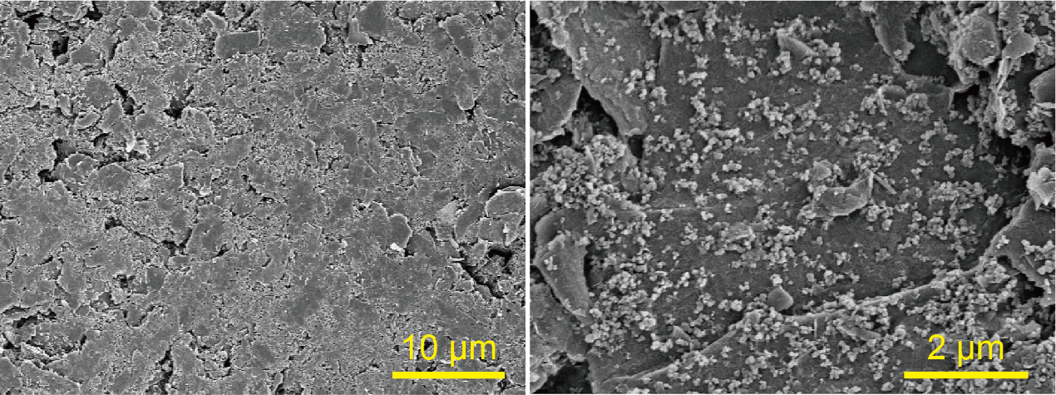

**Fig S1.** SEM images of RNG cathode without cycle.

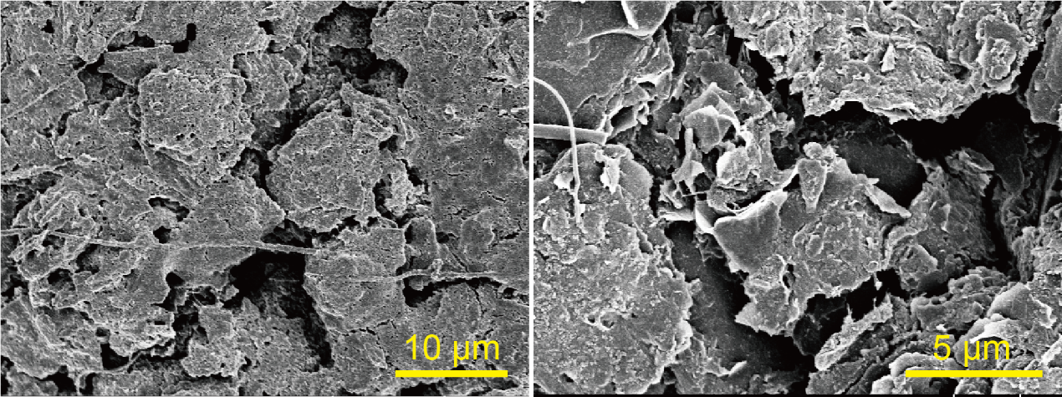

**Fig S2.** SEM images of RNG cathode after 70 cycles.

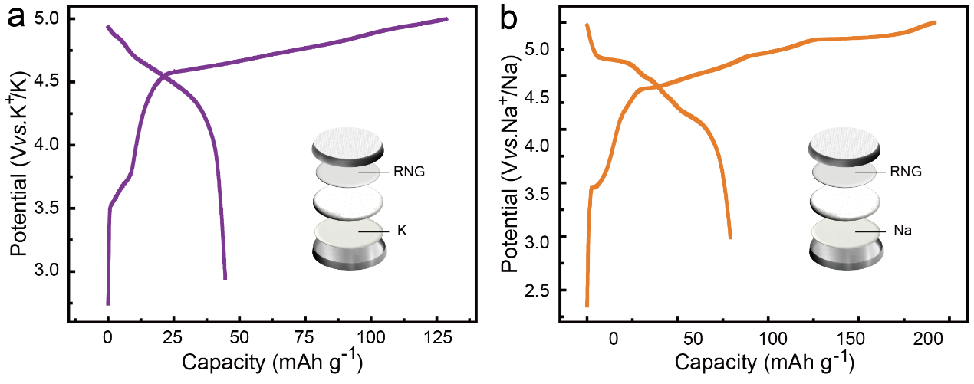

**Fig S3.** Galvanostatic charge-discharge curves of (a) Na-DIBs and (b) K-DIBs.

**Table S5.** Performance of DIBs in Li, Na, and K systems comparison with literature.

|  |  |  |  |  |  |
| --- | --- | --- | --- | --- | --- |
|  | Cathode | Electrolyte | Capacity (mAh g-1) | Specific Current (mA g-1) | Reference |
| Li-DIBs | Graphite KS6 | 3M LiPF6-DMC | ~76 | 200 | [S5] |
| 3M LiPF6-EMC | ~95 | 200 |
| 3M LiPF6-DEC | ~76 | 200 |
| MCMB | 1.7M LiPF6-FEC/EMC/HFIP | ~80 | 500 | [S6] |
| 1M LiPF6-EMC/SUL | ~107 | 50 | [S7] |
| Graphite | 4M LiPF6-EMC/VC | ~90 | 200 | [S8] |
| RNG | 4M LiPF6-EMC/VC | 87 | 200 | This work |
| Na-DIBs | Graphite | 0.8M NaPF6-PC | ~62 | 40 | [S9] |
| Graphite | 3M NaPF6-EC/EMC/FEC | ~94 | 200 | [S10] |
| Graphite | 1M NaPF6-EC/DEC | ~50 | 372 | [S11] |
| RNG | 3M NaPF6-EC/EMC/FEC | 80 | 100 | This work |
| K-DIBs | EG | 1M KPF6-EC/DMC/EMC | ~61 | 100 | [S12] |
| KS6 | 0.8M KPF6-EC/DEC | ~54 | 100 | [S13] |
| Graphite particle (6 μm size) | 1M KPF6-EC/DMC | ~38.4 | 0.4 mA cm-2 | [S14] |
| High-surface-area graphite | 1M KPF6-EC/DMC | ~35.3 |
| C60 | 1M KPF6-EC/DMC | ~47 |
| RNG | 1MKPF6-PC/FEC | 45 | 100 | This work |

**References**

[S1] H.J. Liang, B.H. Hou, W.H. Li, Q.L. Ning, X. Yang, Z.Y. Gu, X.J. Nie, G. Wang, X.L. Wu, Staging Na/K-ion de-/intercalation of graphite retrieved from spent Li-ion batteries: in operando X-ray diffraction studies and an advanced anode material for Na/K-ion batteries. Energ Environ Sci. 2019, 12, 3575-3584.

[S2] M Hart, Bragg reflection x ray optics. Rep. Prog. Phys. 1971, 34, 435.

[S3] A. Heckmann, O. Fromm, U. Rodehorst, P. Munster, M. Winter, T. Placke, New insights into electrochemical anion intercalation into carbonaceous materials for dual-ion batteries: Impact of the graphitization degree. Carbon. 2018, 131, 201-212.

[S4] X. Hou, W. Li, Y. Wang, S. Li, Y. Meng, H. Yu, B. Chen, X. Wu, Sodium-based dual-ion batteries via coupling high-capacity selenium/graphene anode with high-voltage graphite cathode. Chinese Chemical Letters. 2020, 31, 2314-2318.

[S5] Y. Wang, S. Wang, Y. Zhang, P.-K. Lee, D.Y.W. Yu, Unlocking the True Capability of Graphite-Based Dual-Ion Batteries with Ethyl Methyl Carbonate Electrolyte. Acs Appl Energ Mater. 2019, 2, 7512-7517.

[S6] J.A. Read, In-Situ Studies on the Electrochemical Intercalation of Hexafluorophosphate Anion in Graphite with Selective Cointercalation of Solvent. J Phys Chem C. 2015, 119, 8438-8446.

[S7] P. Han, X. Han, J. Yao, L. Yue, J. Zhao, X. Zhou, G. Cui, Mesocarbon microbead based dual-carbon batteries towards low cost energy storage devices. J Power Sources. 2018, 393, 145-151.

[S8] L.N. Wu, J. Peng, Y.K. Sun, F.M. Han, Y.F. Wen, C.G. Shi, J.J. Fan, L. Huang, J.T. Li, S.G. Sun, High-Energy Density Li metal Dual-Ion Battery with a Lithium Nitrate-Modified Carbonate-Based Electrolyte. ACS Appl Mater Interfaces. 2019, 11, 18504-18510.

[S9] Z. Hu, Q. Liu, K. Zhang, L. Zhou, L. Li, M. Chen, Z. Tao, Y.M. Kang, L. Mai, S.L. Chou, J. Chen, S.X. Dou, All Carbon Dual Ion Batteries. ACS Appl Mater Interfaces. 2018, 10, 35978-35983.

[S10] X.K. Hou, S.F. Li, W.H. Li, H.J. Liang, Z.Y. Gu, X.X. Luo, X.L. Wu, Electrolyte Chemistry Towards Improved Cycling Stability in Na‐Based Dual‐Ion Batteries with High‐Power/Energy Storage. Batteries Supercaps. 2021, 4, 1647-1653.

[S11] I. Cameán, N. Cuesta, A.B. García, On the PF6− anion intercalation in graphite from sodium salt-based electrolytes containing different mixtures of organic carbonates. Electrochim Acta. 2021, 384, 138360.

[S12] B. Ji, F. Zhang, N. Wu, Y. Tang, A Dual-Carbon Battery Based on Potassium-Ion Electrolyte. Adv Energy Mater. 2017, 7, 1700920.

[S13] J. Zhu, Y. Li, B. Yang, L. Liu, J. Li, X. Yan, D. He, A Dual Carbon-Based Potassium Dual Ion Battery with Robust Comprehensive Performance. Small. 2018, 14, 1801836.

[S14] T Ishihara, M Koga, H Matsumoto, M Yoshio, Electrochemical intercalation of hexafluorophosphate anion into various carbons for cathode of dual-carbon rechargeable battery. Electrochem. Solid-State Lett. 2007, 10, 74.